**CHAPTER 1**

**INTRODUCTION**

* 1. **OVERVIEW**

The overview of this project is to make a Security access control system using RFID technology, Face recognition technology, Pic microcontroller, embedded and Matlab softwares. Today Pic Microcontroller is commonly used in many projects where a simple, low-powered, low-cost operation is required.

In this documentation we learn about the details of every individual component, circuitry and the technology that were used to develop this project.

Firstly, we learn about the controller part and all the circuit board elements. Then gradually the latter part explains much about the Rfid and Face recognition technologies being used.

Lastly, the software part and the codes used to run the project is briefly explained with the working part clearly depicted for easy understanding of the project.

* 1. **MOTIVATION**

The project aims in designing a completely automated security access system for domestic and industrial applications. Security is the bigger concern for an individual or a firm. Recognizing the need of security we developed an automated security access system with user friendly access. The project aims at designing an intelligent security system for door unlocking. The proposed system makes use of Face Recognition technology for identifying the user and also using RFID identification technology. The Intelligent system proposed makes use of both Embedded and Matlab to achieve the task.

* 1. **OBJECTIVE**

The Objective of the current work is to implement a security access control system using an Rfid reader, Rfid cards, Face recognition, Pic controller, motors and buzzers. The inputs from PC and Rfid reader are given to the controller and are processed by using code dumped in the controller and then correspondingly the access control system is established either to grant or deny the access.

The Microcontroller unlocks the door, if the user is valid both using face recognition and also using RFID identification details gets matched. The Microcontroller alerts the user with a beep sound, if the facial identity is not found in the database. Different operations being performed can be seen through LCD display.

* 1. **SCOPE**

The project can be extended using GPRS technology. The system sends messages to the predefined weblink. In this type of future scope the two level proposed security access control system can be operated using the internet through which the owner can control the system over long ranges just by using the lan and other services.

The project can be extended using wireless camera which can detect the person through camera. The wireless camera then sends the pictures of the person to the destined IP address.

**CHAPTER 2**

**LITERATURE SURVEY**

[1]. This is Journal that proposed the design of Rfid and Face recognition based security access system. In this journal the Researcher combined the two different security access systems in order to increase up the level of security. This journal provided us the idea to go forth and implement the project.

[2]. In this paper novel image retrieval techniques based on features extracted from Kekre transform applied on row mean, column mean and combination are presented. We have learnt four methods of image retrieval, that are as follows full Kekre Transform, Kekre Transform Row Mean, Kekre Transform Column Mean and Kekre Transform Row Mean Column Mean CBIR.

[3]. This paper proposes a content-based image retrieval system based on an efficient combination of both feature and color algorithms. According to Kekre Transform we derived feature vectors using a combination of row mean and column mean of both query as well as the database images, to measure the extent of similarity in features using Euclidian distance. Taking mean or Euclidian distance of the individual Euclidian distances of both the algorithms improves the accuracy of the image retrieval process implemented.

[4]. Since we are using a PIC microcontroller of 16f series, this site had provided us the best of the details and tutorials related to the controller. We explored the PIC family of micro controllers and decided to work upon our enhanced mid-range controller after the clear details of architecture, peripherals and features provided by this site.

[5]. This site “Intro to RFID”, has helped us a lot in understanding of the rfid technology and its applications. Since, Rfid being the important component in our project, we couldn’t expect a much better and detailed tutorials of Rfid readers and tags.

Many important features, various applications were learnt from this site. Experimentation on simple applications using the Rfid readers and tags helped us to use it in a effective way .

[6]. The DC motors were used in our project as a representation of the security access control system that unlocks when the access is granted. The DC motor used had to be interfaced with the PIC controller, but the controlling is done with the L293d driver circuit. This Document provided us with the relative schematics and the interfacing of the driver circuits with the motors.

[7]. In our project the status of the circuitry and the response from the microcontroller is displayed on the LCD. We used a HD44780 display that has 16 pins. The necessary interafacing of the lcd with the microcontroller was learnt here. The essential library files to be used while employing the lcd in our project was downloaded from here. The code and the driver files were also provided by this link.

[8]. From the first two links we were introduced to the Face recognition and its procedural functionalities. We have earlier learnt the Face recognition process using the kekre transform. To use this method in the matlab software we needed to prepare the code. This link has provided us with the Kekre Transform M-file and .fig file. We used these files to implement the Facial recognition algorithm using Kekre Transform in the Matlab software.

**CHATER 3**

**BLOCK DIAGRAM**

In this chapter the block diagram of the project and design aspect of independent modules are considered. Block diagram is shown in the figure below.

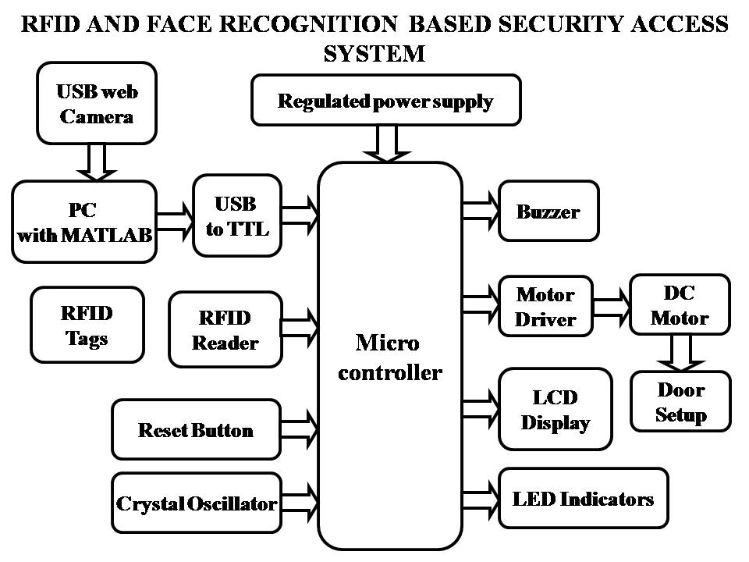

**FIG 1: Block diagram of RFID and** **Face recognition system based security access system**

**CHAPTER 4**

**HARDWARE COMPONENTS**

The main blocks of this project are:

1. Micro controller (16F72)
2. Reset button
3. Crystal oscillator
4. Regulated power supply (RPS)
5. LED indicator.
6. DC motor
7. LCD.
8. USB to TTL
9. Buzzer
10. RFID module

**4.1 PIC Micro controller:**

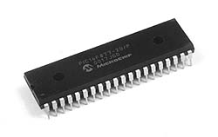

**Fig 2: Microcontrollers**

**MICROCONTROLLER**

A Microcontroller is a programmable digital processor with necessary peripherals. Both microcontrollers and microprocessors are complex sequential digital circuits meant to carry out job according to the program / instructions. Sometimes analog input/output interface makes a part of microcontroller circuit of mixed mode (both analog and digital nature).

**4.1.1.Introduction:**

The PIC16F72 CMOS FLASH-based 8-bit microcontroller is upward compatible with PIC16C72/72A and PIC16F872devices. It features 200 ns instruction execution, self programming, an ICD, 2 Comparators, 5 channels of 8-bit Analog-to-Digital (A/D) converter, 2 capture/compare/PWM functions, a synchronous serial port that can be configured as either 3-wire SPI or 2-wire I2C bus, a USART, and a Parallel Slave Port.

• High performance RISC CPU

• Only 35 single word instructions to learn

• All single cycle instructions except for program branches which are two-cycle

• Operating speed: DC - 20 MHz clock input DC - 200 ns instruction cycle

• 2K x 14 words of Program Memory

128 x 8 bytes of Data Memory (RAM)

• Pin out compatible to the PIC16C72/72A and PIC16F872

• Interrupt capability

• Eight level deep hardware stack

• Direct, Indirect and Relative Addressing modes

**Peripheral Features**

• Timer0: 8-bit timer/counter with 8-bit prescaler

• Timer1: 16-bit timer/counter with prescaler, can be incremented during SLEEP via

external crystal/clock

• Timer2: 8-bit timer/counter with 8-bit period register, prescaler and postscaler

• Capture, Compare, PWM(CCP) module

- Capture is 16-bit, max resolution is 12.5 ns

- Compare is 16-bit, max resolution is 200 ns

- PWM max resolution is 10-bit

• 8-bit, 5-channel Analog-to-Digital converter

• Synchronous Serial Port (SSP) with SPI (Master mode) and I2C (Slave)

• Heat sink/Source Current: 25 mA

• Brown-out detection circuitry for Brown-out Reset (BOR)

**CMOS Technology:**

• Low power, high speed CMOS FLASH technology

• Fully static design

• Wide operating voltage range: 2.0V to 5.5V

• Industrial temperature range

• Low power consumption:

- < 0.6 mA typical @ 3V, 4 MHz

- 20 μA typical @ 3V, 32 kHz

-Following are the major blocks of PIC Microcontroller.

**Program memory** (FLASH) is used for storing a written program.   
Since memory made in FLASH technology can be programmed and cleared more than once, it makes this microcontroller suitable for device development.   
  
**EEPROM** - data memory that needs to be saved when there is no supply.  
It is usually used for storing important data that must not be lost if power supply suddenly stops. For instance, one such data is an assigned temperature in temperature regulators. If during a loss of power supply this data was lost, we would have to make the adjustment once again upon return of supply. Thus our device looses on self-reliance.   
  
**RAM**- Data memory used by a program during its execution

In RAM are stored all inter-results or temporary data during run-time.

PORTS are physical connections between the microcontroller and the outside world. PIC16F72 has 22 I/O.

**FREE-RUN TIMER** is an 8-bit register inside a microcontroller that works independently of the program. On every fourth clock of the oscillator it increments its value until it reaches the maximum (255), and then it starts counting over again from zero. As we know the exact timing between each two increments of the timer contents, timer can be used for measuring time which is very useful with some devices.   
  
**Crystal oscillator:**

The crystal oscillator speed that can be connected to the PIC microcontroller range from DC to 20Mhz. Using the CCS C compiler normally 20Mhz oscillator will be used and the price is very cheap. The 20 MHz crystal oscillator should be connected with about 22pF capacitor. Please refer to my circuit schematic.

There are 5 input/output ports on PIC microcontroller namely port A, port B, port C, port D and port E. Each port has different function. Most of them can be used as I/O port.

**Clock / instruction cycle**

Clock from the oscillator enters a microcontroller via OSC1 pin where internal circuit of a microcontroller divides the clock into four even clocks Q1, Q2, Q3, and Q4 which do not overlap. These four clocks make up one instruction cycle (also called machine cycle) during which one instruction is executed.

Execution of instruction starts by calling an instruction that is next in string. Instruction is called from program memory on every Q1 and is written in instruction register on Q4. Decoding and execution of instruction are done between the next Q1 and Q4 cycles. On the following diagram we can see the relationship between instruction cycle and clock of the oscillator (OSC1) as well as that of internal clocks Q1-Q4. Program counter (PC) holds information about the address of the next instruction.

FIG-3

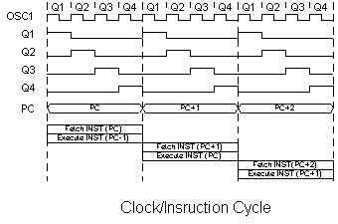  
**Pipelining**

Instruction cycle consists of cycles Q1, Q2, Q3 and Q4. Cycles of calling and executing instructions are connected in such a way that in order to make a call, one instruction cycle is needed, and one more is needed for decoding and execution. However, due to pipelining, each instruction is effectively executed in one cycle.

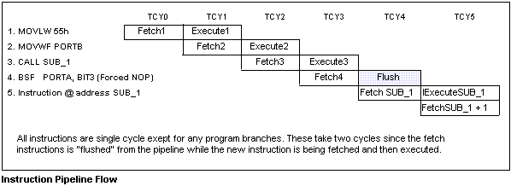

**4.1.2.Pin description**

PIC16F72 has a total of 28 pins. It is most frequently found in a DIP28 type of case but can also be found in SMD case which is smaller from a DIP. DIP is an abbreviation for Dual In Package. SMD is an abbreviation for Surface Mount Devices suggesting that holes for pins to go through when mounting aren't necessary in soldering this type of a component.

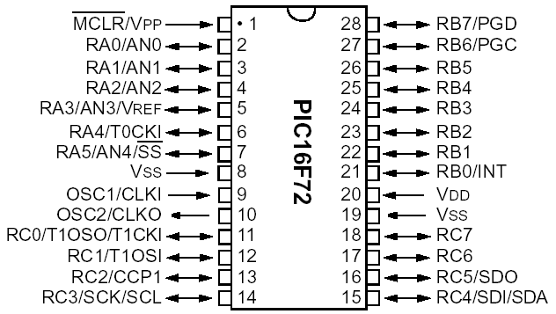

**Fig: 4**

Pins on PIC16F72 microcontroller have the following meaning:  
  
 There are 28 pins on PIC16F72. Most of them can be used as an IO pin. Others are already for specific functions. These are the pin functions.  
1. MCLR – to reset the PIC  
2. RA0 – port A pin 0  
3. RA1 – port A pin 1  
4. RA2 – port A pin 2  
5. RA3 – port A pin 3  
6. RA4 – port A pin 4  
7. RA5 – port A pin 5  
8. VSS – ground  
9. OSC1 – connect to oscillator  
10. OSC2 – connect to oscillator  
11. RC0 – port C pin 0 VDD – power supply  
12. RC1 – port C pin 1  
13. RC2 – port C pin 2  
14. RC3 – port C pin 3  
15. RC4 - port C pin 4  
16. RC5 - port C pin 5  
17. RC6 - port C pin 6  
18. RC7 - port C pin 7  
19. VSS - ground  
20. VDD – power supply  
21. RB0 - port B pin 0  
22. RB1 - port B pin 1  
23. RB2 - port B pin 2  
24. RB3 - port B pin 3  
25. RB4 - port B pin 4  
26. RB5 - port B pin 5  
27. RB6 - port B pin 6  
28. RB7 - port B pin 7

By utilizing all of this pin so many applications can be done such as:  
1. LCD – connect to Port B pin.  
2. LED – connect to any pin declared as output.  
3. Relay and Motor - connect to any pin declared as output.  
4. External EEPROM – connect to I2C interface pin – RC3 and RC4 (SCL and SDA)   
5. LDR, Potentiometer and sensor – connect to analogue input pin such as RA0.  
6. GSM modem dial up modem – connect to RC6 and RC7 – the serial communication interface using RS232 protocol.

**4.1.3.PORTS**

Term "port" refers to a group of pins on a microcontroller which can be accessed simultaneously, or on which we can set the desired combination of zeros and ones, or read from them an existing status. Physically, port is a register inside a microcontroller which is connected by wires to the pins of a microcontroller. Ports represent physical connection of Central Processing Unit with an outside world.

All port pins can be designated as input or output, according to the needs of a device that's being developed. In order to define a pin as input or output pin, the right combination of zeros and ones must be written in TRIS register. If the appropriate bit of TRIS register contains logical "1", then that pin is an input pin, and if the opposite is true, it's an output pin. Every port has its proper TRIS register. Thus, port A has TRISA, and port B has TRISB. Pin direction can be changed during the course of work which is particularly fitting for one-line communication where data flow constantly changes direction.

**PORTB and TRISB**

PORTB have adjoined 8 pins. The appropriate register for data direction is TRISB. Setting a bit in TRISB register defines the corresponding port pin as input, and resetting a bit in TRISB register defines the corresponding port pin as output.

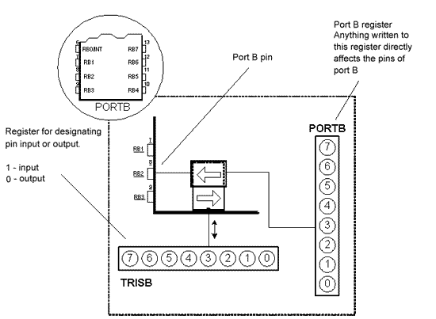

Fig: 5

Each PORTB pin has a weak internal pull-up resistor (resistor which defines a line to logic one) which can be activated by resetting the seventh bit RBPU in OPTION register. These 'pull-up' resistors are automatically being turned off when port pin is configured as an output. When a microcontroller is started, pull-ups are disabled.

Four pins PORTB, RB7:RB4 can cause an interrupt which occurs when their status changes from logical one into logical zero and opposite. Only pins configured as input can cause this interrupt to occur (if any RB7:RB4 pin is configured as an output, an interrupt won't be generated at the change of status.) This interrupt option along with internal pull-up resistors makes it easier to solve common problems we find in practice like for instance that of matrix keyboard. If rows on the keyboard are connected to these pins, each push on a key will then cause an interrupt. A microcontroller will determine which key is at hand while processing an interrupt It is not recommended to refer to port B at the same time that interrupt is being processed.

**PORTA and TRISA**

PORTA have 5 adjoining pins. The corresponding register for data direction is TRISA at address 85h. Like with port B, setting a bit in TRISA register defines also the corresponding port pin as input, and clearing a bit in TRISA register defines the corresponding port pin as output.

It is important to note that PORTA pin RA4 can be input only. On that pin is also situated an external input for timer TMR0. Whether RA4 will be a standard input or an input for a counter depends on T0CS bit (TMR0 Clock Source Select bit). This pin enables the timer TMR0 to increment either from internal oscillator or via external impulses on RA4/T0CKI pin.

Example shows how pins 0, 1, 2, 3, and 4 are designated input, and pins 5, 6, and 7 outputs. After this, it is possible to read the pins RA2, RA3, RA4, and to set logical zero or one to pins RA0 and RA1.

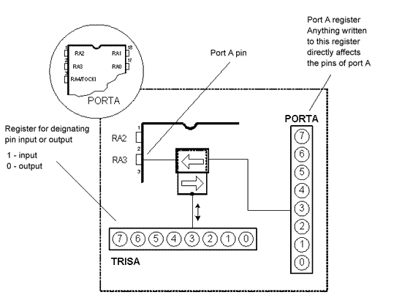

Fig: 6

**4.1.4.Memory organization**

PIC16F72 has two separate memory blocks, one for data and the other for program. EEPROM memory with GPR and SFR registers in RAM memory make up the data block, while FLASH memory makes up the program block.

**4.1.5.Program memory**

Program memory has been carried out in FLASH technology which makes it possible to program a microcontroller many times before it's installed into a device, and even after its installment if eventual changes in program or process parameters should occur. The size of program memory is 1024 locations with 14 bits width where locations zero and four are reserved for reset and interrupt vector.

**4.1.6.Data memory**

Data memory consists of EEPROM and RAM memories. EEPROM memory consists of 256 eight bit locations whose contents are not lost during loosing of power supply. EEPROM is not directly addressable, but is accessed indirectly through EEADR and EEDATA registers. As EEPROM memory usually serves for storing important parameters (for example, of a given temperature in temperature regulators) , there is a strict procedure for writing in EEPROM which must be followed in order to avoid accidental writing. RAM memory for data occupies space on a memory map from location 0x0C to 0x4F which comes to 68 locations. Locations of RAM memory are also called GPR registers which is an abbreviation for General Purpose Registers. GPR registers can be accessed regardless of which bank is selected at the moment.

**4.1.7.Applications**

PIC16F72 perfectly fits many uses, from automotive industries and controlling home appliances to industrial instruments, remote sensors, electrical door locks and safety devices. It is also ideal for smart cards as well as for battery supplied devices because of its low consumption.

EEPROM memory makes it easier to apply microcontrollers to devices where permanent storage of various parameters is needed (codes for transmitters, motor speed, receiver frequencies, etc.). Low cost, low consumption, easy handling and flexibility make PIC16F72 applicable even in areas where microcontrollers had not previously been considered (example: timer functions, interface replacement in larger systems, coprocessor applications, etc.).

In System Programmability of this chip (along with using only two pins in data transfer) makes possible the flexibility of a product, after assembling and testing have been completed. This capability can be used to create assembly-line production, to store calibration data available only after final testing, or it can be used to improve programs on finished products.

**4.2. Regulated Power Supply**

**4.2.1 Introduction:**

Power supply is a supply of electrical power. A device or system that supplies electrical or other types of energy to an output load or group of loads is called a power supply unit or PSU. The term is most commonly applied to electrical energy supplies, less often to mechanical ones, and rarely to others.

A power supply may include a power distribution system as well as primary or secondary sources of energy such as

* Batteries.
* Chemical fuel cells and other forms of energy storage systems.
* Solar power.
* Generators or alternators.

**4.2.2 Block Diagram:**

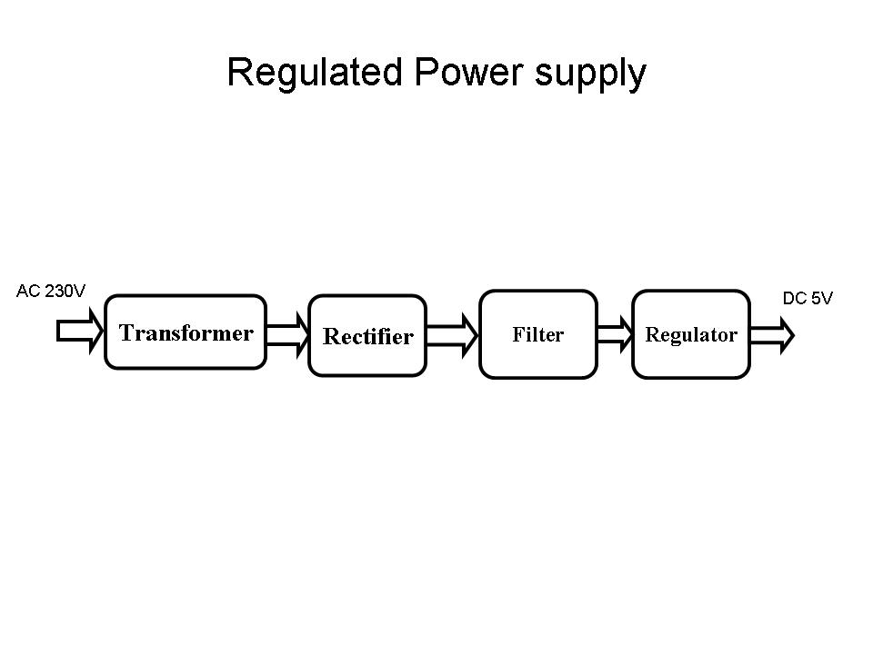

**Fig 7- Regulated Power Supply**

The basic circuit diagram of a regulated power supply (DC O/P) with led connected as load is shown in figure.

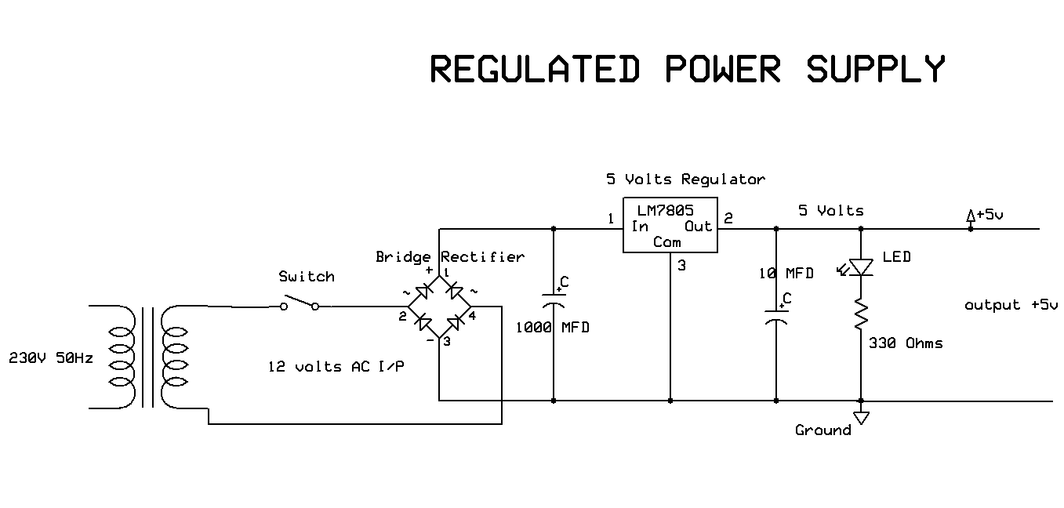

**Fig 8 Circuit diagram of Regulated Power Supply with Led connection**

The components mainly used in above figure are

* 230V AC MAINS
* TRANSFORMER
* BRIDGE RECTIFIER(DIODES)
* CAPACITOR
* VOLTAGE REGULATOR(IC 7805)
* RESISTOR
* LED(LIGHT EMITTING DIODE)

The detailed explanation of each and every component mentioned above is as follows:

**Transformation:** The process of transforming energy from one device to another is called transformation. For transforming energy we use transformers.

**4.2.3 Transformers:**

A transformer is a device that transfers electrical energy from one circuit to another through inductively coupled conductors without changing its frequency. A varying current in the first or primary winding creates a varying magnetic flux in the transformer's core, and thus a varying magnetic field through the secondary winding. This varying magnetic field induces a varying electromotive force (EMF) or "voltage" in the secondary winding. This effect is called mutual induction.

If the current is increased, the lines of force move outwards from the coil. If the current is reduced, the lines of force move inwards.

If another coil is placed adjacent to the first coil then, as the field moves out or in, the moving lines of force will "cut" the turns of the second coil. As it does this, a voltage is induced in the second coil. With the 50 Hz AC mains supply, this will happen 50 times a second. This is called MUTUAL INDUCTION and forms the basis of the transformer.

The input coil is called the PRIMARY WINDING; the output coil is the SECONDARY WINDING.

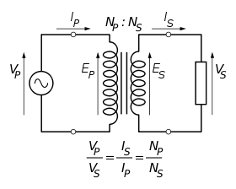

**Fig 9: Step-Down Transformer**

The voltage induced in the secondary is determined by the TURNS RATIO.

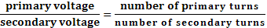

If the primary voltage is 240 volts then the secondary voltage will be x 10 smaller = 24 volts. Assuming a perfect transformer, the power provided by the primary must equal the power taken by a load on the secondary. If a 24-watt lamp is connected across a 24 volt secondary, then the primary must supply 24 watts.

Note that the transformer only works on AC, which has a constantly changing current and moving field. DC has a steady current and therefore a steady field and there would be no induction.

**Step Up transformer:**

In case of step up transformer, primary windings are every less compared to secondary winding.Because of having more turns secondary winding accepts more energy, and it releases more voltage at the output side.

**Step down transformer:**

In case of step down transformer, Primary winding induces more flux than the secondary winding, and secondary winding is having less number of turns because of that it accepts less number of flux, and releases less amount of voltage.

**4.2.4.Battery power supply:**

A battery is a type of linear power supply that offers benefits that traditional line-operated power supplies lack: mobility, portability and reliability. A battery consists of multiple electrochemical cells connected to provide the voltage desired. Fig: 2.3.5 shows Hi-Watt 9V battery

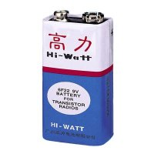

Fig 10

The lead-acid storage battery may be used. This battery is rechargeable; it consists of lead and lead/dioxide electrodes which are immersed in sulfuric acid. When fully charged, this type of battery has a 2.06-2.14 V potential (A 12 volt car battery uses 6 cells in serie

**Rectification:**

The process of converting an alternating current to a pulsating direct current is called as rectification. For rectification purpose we use rectifiers.

**4.2.5.Rectifiers:**

A rectifier is an electrical device that converts alternating current (AC) to direct current (DC), a process known as rectification. Rectifiers have many uses including as components of power supplies and as detectors of radio signals. Rectifiers may be made of solid-state diodes, vacuum tube diodes, mercury arc valves, and other components.

A device that it can perform the opposite function (converting DC to AC) is known as an inverter.

When only one diode is used to rectify AC (by blocking the negative or positive portion of the waveform), the difference between the term diode and the term rectifier is merely one of usage, i.e., the term rectifier describes a diode that is being used to convert AC to DC. Almost all rectifiers comprise a number of diodes in a specific arrangement for more efficiently converting AC to DC than is possible with only one diode. Before the development of silicon semiconductor rectifiers, vacuum tube diodes and copper (I) oxide or selenium rectifier stacks were used.

**Bridge full wave rectifier:**

The Bridge rectifier circuit is shown in fig: 2.3.6, which converts an ac voltage to dc voltage using both half cycles of the input ac voltage. The Bridge rectifier circuit is shown in the figure. The circuit has four diodes connected to form a bridge. The ac input voltage is applied to the diagonally opposite ends of the bridge. The load resistance is connected between the other two ends of the bridge.

For the positive half cycle of the input ac voltage, diodes D1 and D3 conduct, whereas diodes D2 and D4 remain in the OFF state. The conducting diodes will be in series with the load resistance RL and hence the load current flows through RL.

For the negative half cycle of the input ac voltage, diodes D2 and D4 conduct whereas, D1 and D3 remain OFF. The conducting diodes D2 and D4 will be in series with the load resistance RL and hence the current flows through RL in the same direction as in the previous half cycle. Thus a bi-directional wave is converted into a unidirectional wave.

Input Output

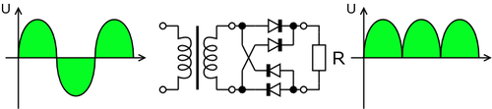

**Fig 11: Bridge rectifier: a full-wave rectifier using 4 diodes**

**DB107:**

Now -a -days Bridge rectifier is available in IC with a number of DB107. In our project we are using an IC in place of bridge rectifier. The picture of DB 107 is shown in fig.

**Features:**

* Good for automation insertion
* Surge overload rating - 30 amperes peak
* Ideal for printed circuit board
* Reliable low cost construction utilizing molded
* Glass passivated device
* Polarity symbols molded on body
* Mounting position: Any
* Weight: 1.0 gram

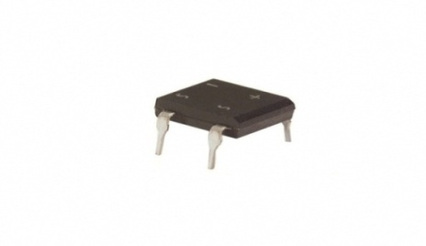

**Fig 12: DB107**

**4.2.6.Capacitors:**

The **Capacitor** or sometimes referred to as a Condenser is a passive device, and one which stores energy in the form of an electrostatic field which produces a potential (static voltage) across its plates. In its basic form a capacitor consists of two parallel conductive plates that are not connected but are electrically separated either by air or by an insulating material called the Dielectric. When a voltage is applied to these plates, a current flows charging up the plates with electrons giving one plate a positive charge and the other plate an equal and opposite negative charge This flow of electrons to the plates is known as the Charging Current and continues to flow until the voltage across the plates (and hence the capacitor) is equal to the applied voltage Vcc. At this point the capacitor is said to be fully charged and this is illustrated below.

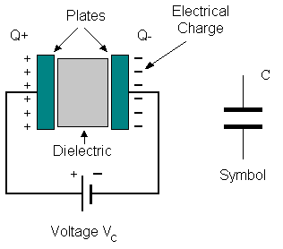

**Fig 13:Construction Of a Capacitor**

**4.2.7.Voltage Regulator:**

A voltage regulator (also called a ‘regulator’) with only three terminals appears to be a simple device, but it is in fact a very complex integrated circuit. It converts a varying input voltage into a constant ‘regulated’ output voltage. Voltage Regulators are available in a variety of outputs like 5V, 6V, 9V, 12V and 15V. The LM78XX series of voltage regulators are designed for positive input. For applications requiring negative input, the LM79XX series is used. Using a pair of ‘voltage-divider’ resistors can increase the output voltage of a regulator circuit. Reverse polarity destroys the regulator almost instantly. Fig: 2.3.9 shows voltage regulator.



**Fig 14: Voltage Regulator**

**4.2.8.Resistors:**

A resistor is a two-terminal electronic component that produces a voltage across its terminals that is proportional to the electric current passing through it in accordance with Ohm's law:

*V* = *IR*

The primary characteristics of a resistor are the resistance, the tolerance, maximum working voltage and the power rating. Other characteristics include temperature coefficient, noise, and inductance. Less well-known is critical resistance, the value below which power dissipation limits the maximum permitted current flow, and above which the limit is applied voltage. Critical resistance is determined by the design, materials and dimensions of the resistor.. Basic unit is ohms.

**4.2.9. LED:**

A light-emitting diode (LED) is a semiconductor light source. LEDs are used as indicator lamps in many devices, and are increasingly used for lighting. Introduced as a practical electronic component in 1962, early LEDs emitted low-intensity red light, but modern versions are available across the visible, ultraviolet and infrared wavelengths, with very high brightness.

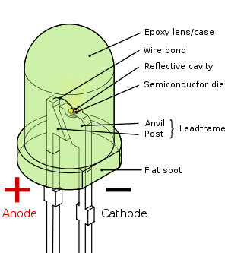

**Fig 15: Parts of a LED**

**Working:**

When a diode is forward biased (switched on), electrons are able to recombine with holes within the device, releasing energy in the form of photons. This effect is called electroluminescence and the color of the light (corresponding to the energy of the photon) is determined by the energy gap of the semiconductor. An LED is usually small in area (less than 1 mm2), and integrated optical components are used to shape its radiation pattern and assist in reflection. LEDs present many advantages over incandescent light sources including lower energy consumption, longer lifetime, improved robustness, smaller size, faster switching, and greater durability and reliability. However, they are relatively expensive and require more precise current and heat management than traditional light sources. Current LED products for general lighting are more expensive to buy than fluorescent lamp sources of comparable output. They also enjoy use in applications as diverse as replacements for traditional light sources in automotive lighting (particularly indicators) and in traffic signals. The compact size of LEDs has allowed new text and video displays and sensors to be developed, while their high switching rates are useful in advanced communications technology.

Applications of LED fall into three major categories:

* Visual signal application where the light goes more or less directly from the LED to the human eye, to convey a message or meaning.
* Illumination where LED light is reflected from object to give visual response of these objects.
* Generate light for measuring and interacting with processes that do not involve the human visual system.

**4.3. USB to TTL converter**

The TTL-232R-3V3 is a USB to TTL serial converter cable incorporating FTDI’s FT232RQ USB - Serial UART interface IC device, the latest device to be added to FTDI’s range of USB UART interface Integrated Circuit Devices. It is designed to allow for a fast, simple way to connect devices with a TTL level serial interface to USB.

**4.3.1.FETAURES:**

The TTL-232R-3V3 uses FTDI’s FT232RQ USB to serial IC device. This section summarises the key features and enhancements of the FT232RQ which apply to the TTL-232R-3V3 USB to serial TTL converter cable.

**Lower Operating and Suspend Current** - The device operating supply current has been further reduced to 15mA, and the suspend current has been reduced to around 70μA. This allows greater margin for peripheral devices incorporating the TTL-232R-3V3 to meet the USB suspend current limit of 500μA.

**Low USB Bandwidth Consumption** - The operation of the USB interface to the FT232R IC, and thus the TTL-232R- 3V3 has been designed to use as little as possible of the total USB bandwidth available from the USB host controller.

**High Output Drive Option** - The UART interface I/O pins on the TTL-232R-3V3 (RXD, TXD, RTS#, and CTS#) are configured to use the FT232R’s high output drive option. This option makes the FT232R I.C.’s I/O pins drive out at three times the standard signal drive level thus allowing multiple devices to be driven, or devices that require a greater signal drive strength to be interfaced to the FT232R.. **Programmable Receive Buffer Timeout** - The receive buffer timeout is used to flush remaining data from the receive buffer. This time defaults to 16ms, but is programmable over USB in 1ms increments from 1ms to 255ms, thus allowing the device to be optimised for protocols that require fast response times from short data packets.

**Baud Rates** - The TTL-232R-3V3 supports all standard baud rates and non-standard baud rates from 300 Baud up to 3 Megabaud. Achievable non-standard baud rates are calculated as follows - Baud Rate = 3000000 / (n + x)

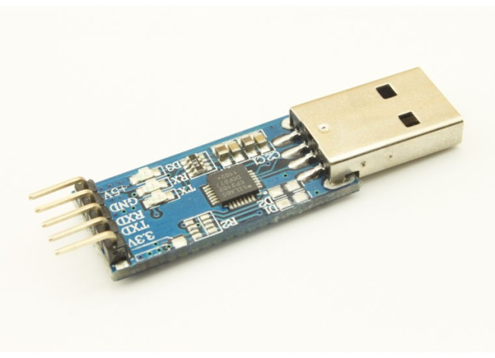

Fig16:Usb to ttl converter

**4.3.2. TTL 232R PIN Description**

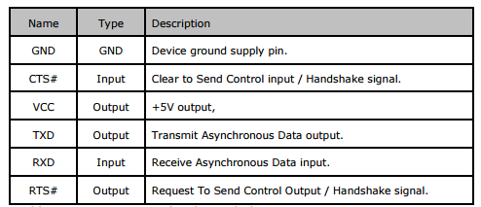

**4.3.3. Specifications** :

* TTL-232R Converter Cable provides a USB to TTL Serial interface with various end connectors.
* On board FT232RQ provides single chip USB to asynchronous serial data transfer interface. Entire USB protocol handled by the electronics in the cable USB.
* Connect directly to a microcontroller UART or I/O pins.
* UART interface support for 7 or 8 data bits, 1 or 2 stop bits and odd / even / mark / space / no parity.
* Fully assisted hardware (RTS#/CTS#) or X-On / X-Off software handshaking.
* Data transfer rates from 300 baud to 3 Mbaud at TTL levels.
* Internal EEPROM with user writeable area.
* 5V CMOS drive outputs and 5V safe TTL inputs makes the TTL-232R easy to interface to 5V MCU‟s.
* FTDI‟s royalty-free VCP allow for communication as a standard emulated COM port and D2XX „direct‟ drivers provide DLL application programming interface.
* Support for FT232R FTDIChip-ID™ feature for improved security.
* +5V or +3.3V output allows external logic to be powered from the USB port.
* 6 way outputs provide Tx, Rx, RTS#, CTS#, VCC and GND (except Audio Jack which provides only TX,RX and GND).
* 8 way, keyed connector to support FTDI VDRIVE2 and VMUSIC2.
* way Audio Jack connector provides Tx, Rx and GND.
* Low USB bandwidth consumption.
* UHCI / OHCI / EHCI host controller compatible.
* USB 2.0 Full Speed compatible.
* -40°C to +85°C operating temperature range

**4.4. LCD**

**LCD Background:**

One of the most common devices attached to a micro controller is an LCD display. Some of the most common LCD’s connected to the many microcontrollers are 16x2 and 20x2 displays. This means 16 characters per line by 2 lines and 20 characters per line by 2 lines, respectively.

**4.4.1.Basic 16x 2 Characters LCD**

**Figure : LCD Pin diagram**

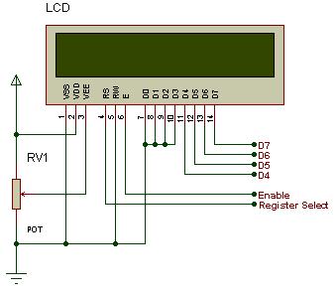

**Fig 17: LCD**

**4.4.2. Pin description:**

|  |  |  |
| --- | --- | --- |
| **Pin No.** | **Name** | **Description** |
| Pin no. 1 | **VSS** | Power supply (GND) |
| Pin no. 2 | **VCC** | Power supply (+5V) |
| Pin no. 3 | **VEE** | Contrast adjust |
| Pin no. 4 | **RS** | 0 = Instruction input 1 = Data input |
| Pin no. 5 | **R/W** | 0 = Write to LCD module 1 = Read from LCD module |
| Pin no. 6 | **EN** | Enable signal |
| Pin no. 7 | **D0** | Data bus line 0 (LSB) |
| Pin no. 8 | **D1** | Data bus line 1 |
| Pin no. 9 | **D2** | Data bus line 2 |
| Pin no. 10 | **D3** | Data bus line 3 |
| Pin no. 11 | **D4** | Data bus line 4 |
| Pin no. 12 | **D5** | Data bus line 5 |
| Pin no. 13 | **D6** | Data bus line 6 |
| Pin no. 14 | **D7** | Data bus line 7 (MSB) |

**Table : Character LCD pins with Microcontroller**

The LCD requires 3 control lines as well as either 4 or 8 I/O lines for the data bus. The user may select whether the LCD is to operate with a 4-bit data bus or an 8-bit data bus. If a 4-bit data bus is used the LCD will require a total of 7 data lines (3 control lines plus the 4 lines for the data bus). If an 8-bit data bus is used the LCD will require a total of 11 data lines (3 control lines plus the 8 lines for the data bus). The three control lines are referred to as **EN**, **RS**, and **RW**.

The **EN** line is called "Enable." This control line is used to tell the LCD that we are sending it data. To send data to the LCD, our program should make sure this line is low (0) and then set the other two control lines and/or put data on the data bus. When the other lines are completely ready, bring **EN** high (1) and wait for the minimum amount of time required by the LCD datasheet (this varies from LCD to LCD), and end by bringing it low (0) again.

The **RS** line is the "Register Select" line. When RS is low (0), the data is to be treated as a command or special instruction (such as clear screen, position cursor, etc.). When RS is high (1), the data being sent is text data which should be displayed on the screen. For example, to display the letter "T" on the screen we would set RS high.

The **RW** line is the "Read/Write" control line. When RW is low (0), the information on the data bus is being written to the LCD. When RW is high (1), the program is effectively querying (or reading) the LCD. Only one instruction ("Get LCD status") is a read command. All others are write commands--so RW will almost always be low.

Finally, the data bus consists of 4 or 8 lines (depending on the mode of operation selected by the user). In the case of an 8-bit data bus, the lines are referred to as DB0, DB1, DB2, DB3, DB4, DB5, DB6, and DB7.

**4.4.3. Schematic:**

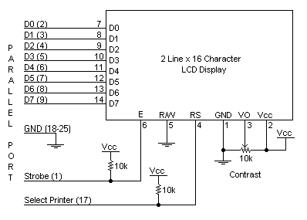

**Fig.18**

**4.4.4. Circuit Description:**

Above is the quite simple schematic. The LCD panel's Enable and RegisterSelect is connected to the Control Port. The Control Port is an open collector / open drain output. While most Parallel Ports have internal pull-up resistors, there is a few which don't. Therefore by incorporating the two 10K external pull up resistors, the circuit is more portable for a wider range of computers, some of which may have no internal pull up resistors.

We make no effort to place the Data bus into reverse direction. Therefore we hard wire the R/W line of the LCD panel, into write mode. This will cause no bus conflicts on the data lines. As a result we cannot read back the LCD's internal Busy Flag which tells us if the LCD has accepted and finished processing the last instruction. This problem is overcome by inserting known delays into our program.

The 10k Potentiometer controls the contrast of the LCD panel. Nothing fancy here. As with all the examples, I've left the power supply out. We can use a bench power supply set to 5v or use an onboard +5 regulator. Remember a few de-coupling capacitors, especially if we have trouble with the circuit working properly.

**SETB RW**

Handling the EN control line:

As we mentioned above, the EN line is used to tell the LCD that we are ready for it to execute an instruction that we've prepared on the data bus and on the other control lines. Note that the EN line must be raised/ lowered before/after each instruction sent to the LCD regardless of whether that instruction is read or write text or instruction. In short, we must always manipulate EN when communicating with the LCD. EN is the LCD's way of knowing that we are talking to it. If we don't raise/lower EN, the LCD doesn't know we're talking to it on the other lines.

Thus, before we interact in any way with the LCD we will always bring the **EN** line low with the following instruction:

**CLR EN**

And once we've finished setting up our instruction with the other control lines and data bus lines, we'll always bring this line high:

**SETB EN**

The line must be left high for the amount of time required by the LCD as specified in its datasheet. This is normally on the order of about 250 nanoseconds, but checks the datasheet. In the case of a typical microcontroller running at 12 MHz, an instruction requires 1.08 microseconds to execute so the EN line can be brought low the very next instruction. However, faster microcontrollers (such as the DS89C420 which executes an instruction in 90 nanoseconds given an 11.0592 MHz crystal) will require a number of NOPs to create a delay while EN is held high. The number of NOPs that must be inserted depends on the microcontroller we are using and the crystal we have selected.

The instruction is executed by the LCD at the moment the EN line is brought low with a final CLR EN instruction.

**Checking the busy status of the LCD:**

As previously mentioned, it takes a certain amount of time for each instruction to be executed by the LCD. The delay varies depending on the frequency of the crystal attached to the oscillator input of the LCD as well as the instruction which is being executed.

While it is possible to write code that waits for a specific amount of time to allow the LCD to execute instructions, this method of "waiting" is not very flexible. If the crystal frequency is changed, the software will need to be modified. A more robust method of programming is to use the "Get LCD Status" command to determine whether the LCD is still busy executing the last instruction received.

The "Get LCD Status" command will return to us two tidbits of information; the information that is useful to us right now is found in DB7. In summary, when we issue the "Get LCD Status" command the LCD will immediately raise DB7 if it's still busy executing a command or lower DB7 to indicate that the LCD is no longer occupied. Thus our program can query the LCD until DB7 goes low, indicating the LCD is no longer busy. At that point we are free to continue and send the next command.

**4.4.5.Applications:**

* Medical equipment
* Electronic test equipment
* Industrial machinery Interface
* Serial terminal
* Advertising system
* EPOS
* Restaurant ordering systems
* Gaming box
* Security systems
* R&D Test units
* Climatizing units
* PLC Interface
* Simulators
* Environmental monitoring
* Lab development
* Student projects
* Home automation
* PC external display
* HMI operator interface.

**4.5. BUZZER**

A buzzer or beeper is an audio signaling device, which may be mechanical, electromechanical, or piezoelectric. Typical uses of buzzers and beepers include alarm devices, timers and confirmation of user input such as a mouse click or keystroke.

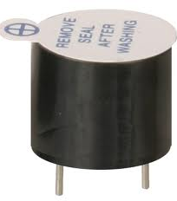

Fig 19: picture of buzzer

A piezoelectric element may be driven by an oscillating electronic circuit or other audio signal source, driven with a piezoelectric audio amplifier. Sounds commonly used to indicate that a button has been pressed are a click, a ring or a beep. **Piezo buzzer** is an electronic device commonly used to produce sound. Light weight, simple construction and low price make it usable in various applications like car/truck reversing indicator, computers, call bells etc.



Basically, the sound source of a piezoelectric sound component is a piezoelectric diaphragm as shown in fig(1). A piezoelectric diaphragm consists of a piezoelectric ceramic plate which has electrodes on both sides and a metal plate (brass or stainless steel, etc.).

A piezoelectric ceramic plate is attached to a metal plate with adhesives. Applying D.C. voltage between electrodes of a piezoelectric diaphragm causes mechanical distortion due to the piezoelectric effect. For a misshaped piezoelectric element, the distortion of the piezoelectric element expands in a radial direction. And the piezoelectric diaphragm bends toward the direction. The metal plate bonded to the piezoelectric element does not expand.

Conversely, when the piezoelectric element shrinks, the piezoelectric diaphragm bends in the direction Thus, when AC voltage is applied across electrodes, the bending is repeated, producing sound waves in the air.

Buzzers typically provide a user with an alert when a given condition within the circuit has occurred. Normally man’s audible frequency range is 20Hz to 20kHz , but we can hear up to frequency ranges from 2kHz to 4kHz .

To interface a buzzer the standard transistor interfacing circuit is used(Fig 2). Note that if a different power supply is used for the buzzer, the 0V rails of each power supply must be connected to provide a common reference. If a battery is used as the power supply, it is worth remembering that piezo sounders draw much less current than buzzers. Buzzers also just have one ‘tone’, whereas a piezo sounder is able to create sounds of many different tones. Here transistor acts as a switch.

To switch on buzzer -high 1

To switch off buzzer -low 1

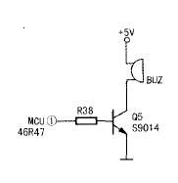

Fig20:. Buzzer with transistor interfacing circuit

**Notice (Handling) In Using Self Drive Method:**

1) When the piezoelectric buzzer is set to produce intermittent sounds, sound may be heard continuously even when the self drive circuit is turned ON / OFF at the "X" point shown in Fig(b). This is because of the failure of turning off the feedback voltage.

2) Build a circuit of the piezoelectric sounder exactly as per the recommended circuit shown in the catalog. Life of the transistor and circuit constants is designed to ensure stable oscillation of the piezoelectric sounder.

3) Design switching which ensures direct power switching.

4) The self drive circuit is already contained in the piezoelectric buzzer. So there is no need to prepare another circuit to drive the piezoelectric buzzer.

5) Rated voltage (3.0 to 20Vdc) must be maintained. Products which can operate with voltage higher than 20Vdc are also available.

6) Do not place resistors in series with the power source, as this may cause abnormal oscillation. If a resistor is essential to adjust sound pressure, place a capacitor (about 1μF) in parallel with the piezo buzzer.

7) Do not close the sound emitting hole on the front side of casing.

8) Carefully install the piezo buzzer so that no obstacle is placed within 15mm from the sound release hole on the front side of the casing.

**4.6.D.C. Motor:**

A dc motor uses electrical energy to produce mechanical energy, very typically through the interaction of magnetic fields and current-carrying conductors. The reverse process, producing electrical energy from mechanical energy, is accomplished by an alternator, generator or dynamo. Many types of electric motors can be run as generators, and vice versa. The input of a DC motor is current/voltage and its output is torque (speed).

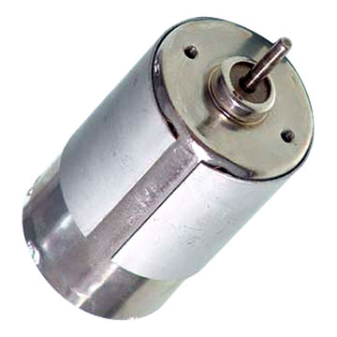

**Fig 21: DC Motor**

The DC motor has two basic parts: the rotating part that is called the armature and the stationary part that includes coils of wire called the field coils. The stationary part is also called the stator. Figure shows a picture of a typical DC motor, Figure shows a picture of a DC armature, and Fig shows a picture of a typical stator. From the picture you can see the armature is made of coils of wire wrapped around the core, and the core has an extended shaft that rotates on bearings. You should also notice that the ends of each coil of wire on the armature are terminated at one end of the armature. The termination points are called the commutator, and this is where the brushes make electrical contact to bring electrical current from the stationary part to the rotating part of the machine.

**4.6.1.Operation:**   
 The DC motor you will find in modem industrial applications operates very similarly to the simple DC motor described earlier in this chapter. Figure 12-9 shows an electrical diagram of a simple DC motor. Notice that the DC voltage is applied directly to the field winding and the brushes. The armature and the field are both shown as a coil of wire. In later diagrams, a field resistor will be added in series with the field to control the motor speed. When voltage is applied to the motor, current begins to flow through the field coil from the negative terminal to the positive terminal. This sets up a strong magnetic field in the field winding. Current also begins to flow through the brushes into a commutator segment and then through an armature coil. The current continues to flow through the coil back to the brush that is attached to other end of the coil and returns to the DC power source. The current flowing in the armature coil sets up a strong magnetic field in the armature.

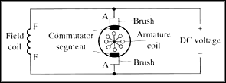

**Fig 22: Simple electrical diagram of DC motor**

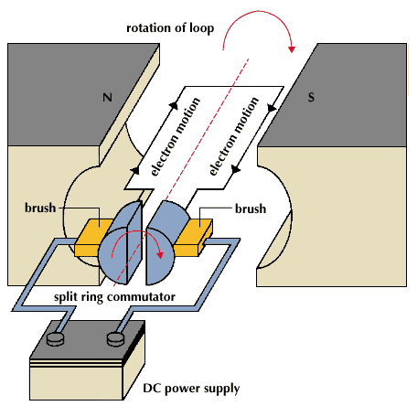  
 **Fig 23: Operation of a DC Motor**

The magnetic field in the armature and field coil causes the armature to begin to rotate. This occurs by the unlike magnetic poles attracting each other and the like magnetic poles repelling each other. As the armature begins to rotate, the commutator segments will also begin to move under the brushes. As an individual commutator segment moves under the brush connected to positive voltage, it will become positive, and when it moves under a brush connected to negative voltage it will become negative. In this way, the commutator segments continually change polarity from positive to negative. Since the commutator segments are connected to the ends of the wires that make up the field winding in the armature, it causes the magnetic field in the armature to change polarity continually from north pole to south pole. The commutator segments and brushes are aligned in such a way that the switch in polarity of the armature coincides with the location of the armature's magnetic field and the field winding's magnetic field. The switching action is timed so that the armature will not lock up magnetically with the field. Instead the magnetic fields tend to build on each other and provide additional torque to keep the motor shaft rotating.   
 When the voltage is de-energized to the motor, the magnetic fields in the armature and the field winding will quickly diminish and the armature shaft's speed will begin to drop to zero. If voltage is applied to the motor again, the magnetic fields will strengthen and the armature will begin to rotate again.

**4.6.2.Applications**

BLDC motors fulfill many functions originally performed by brushed DC motors, but cost and control complexity prevents BLDC motors from replacing brushed motors completely in the lowest-cost areas. Nevertheless, DC motors have come to dominate many applications, particularly devices such as computer [hard drives](http://en.wikipedia.org/wiki/Hard_disk) and CD/DVD players. Small cooling fans in electronic equipment are powered exclusively by BLDC motors. They can be found in cordless power tools where the increased efficiency of the motor leads to longer periods of use before the battery needs to be charged. Low speed, low power BLDC motors are used in [direct-drive turntables](http://en.wikipedia.org/wiki/Direct-drive_turntable) for "analog" audio discs.

**Transport**

High power BLDC motors are found in [electric vehicles](http://en.wikipedia.org/wiki/Electric_vehicle) and [hybrid vehicles](http://en.wikipedia.org/wiki/Hybrid_vehicles).

A number of [electric bicycles](http://en.wikipedia.org/wiki/Electric_bicycles) use BLDC motors that are sometimes built into the wheel hub itself, with the stator fixed solidly to the axle and the magnets attached to and rotating with the wheel. The bicycle wheel hub is the motor. This type of electric bicycle also has a standard bicycle transmission with pedals, sprockets, and chain that can be pedaled along with, or without, the use of the motor as need arises.

**Heating and ventilation**

There is a trend in the [HVAC](http://en.wikipedia.org/wiki/HVAC) and [refrigeration](http://en.wikipedia.org/wiki/Refrigeration) industries to use BLDC motors instead of various types of [AC motors](http://en.wikipedia.org/wiki/AC_motor). The most significant reason to switch to a BLDC motor is the dramatic reduction in power required to operate them versus a typical AC motor.[[8]](http://en.wikipedia.org/wiki/Brushless_DC_electric_motor#cite_note-7)[[9]](http://en.wikipedia.org/wiki/Brushless_DC_electric_motor#cite_note-8) While [shaded-pole](http://en.wikipedia.org/wiki/Shaded-pole) and [permanent split capacitor](http://en.wikipedia.org/wiki/Permanent_split_capacitor) motors once dominated as the fan motor of choice, many fans are now run using a BLDC motor. Some fans use BLDC motors also in order to increase overall system efficiency.[[10]](http://en.wikipedia.org/wiki/Brushless_DC_electric_motor#cite_note-9)

In addition to the BLDC motor's higher efficiency, certain [HVAC](http://en.wikipedia.org/wiki/HVAC) systems (especially those featuring variable-speed and/or load modulation) use BLDC motors because the built-in microprocessor allows for programmability, better control over airflow, and serial communication.

**4.7. DC Motor Driver:**

**4.7.1.H Bridge**

**With switches:**

An H bridge is an electronic circuit that enables a voltage to be applied across a load in either direction. These circuits are often used in robotics and other applications to allow DC motors to run forwards and backwards.

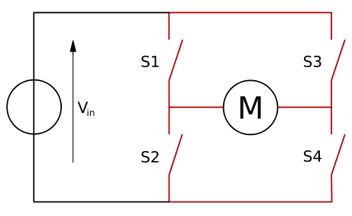

Fig: 24

When the switches S1 and S4 (according to the first figure) are closed (and S2 and S3 are open) a positive voltage will be applied across the motor. By opening S1 and S4 switches and closing S2 and S3 switches, this voltage is reversed, allowing reverse operation of the motor.

Using the nomenclature above, the switches S1 and S2 should never be closed at the same time, as this would cause a short circuit on the input voltage source. The same applies to the switches S3 and S4. This condition is known as shoot-through.

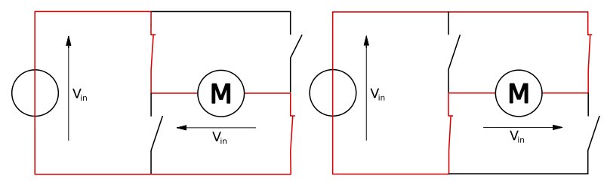

Fig 25

The H-bridge arrangement is generally used to reverse the polarity of the motor, but can also be used to 'brake' the motor, where the motor comes to a sudden stop, as the motor's terminals are shorted, or to let the motor 'free run' to a stop, as the motor is effectively disconnected from the circuit. The following table summarizes operation, with S1-S4 corresponding to the diagram above.

|  |  |  |  |  |
| --- | --- | --- | --- | --- |
| S1 | S2 | S3 | S4 | Result |
| 1 | 0 | 0 | 1 | Motor moves right |
| 0 | 1 | 1 | 0 | Motor moves left |
| 0 | 0 | 0 | 0 | Motor free runs |
| 0 | 1 | 0 | 1 | Motor brakes |
| 1 | 0 | 1 | 0 | Motor brakes |
| 1 | 1 | 0 | 0 | Shoot-through |
| 0 | 0 | 1 | 1 | Shoot-through |
| 1 | 1 | 1 | 1 | Shoot-through |

**4.7.2.H-Bridge Devices**

The L293 has 2 H-Bridges, can provide about 1amp to each and occasional peak loads to 2 amps. Motors typically controlled with this controller are near the size of a 35 mm film plastic canister.

The L298 has 2 h-bridges on board, can handle 1amp and peak current draws to about 3amps. You often see motors between the size a of 35 mm film plastic canister and a coke can, driven by this type H-Bridge. The LMD18200 has one h-bridge on board, can handle about 2 or 3 amps and can handle a peak of about 6 amps. This H-Bridge chip can usually handle an average motor about the size of a coke. There are several more commercially designed H-Bridge chips as well.

**4.7.3.Features:**

• Delivers up to 5 A continuous 6 A peak current

• Optimized for DC motor management applications

• Operates at supply voltages up to 40 V

• Very low RDS ON

• Output full short circuit protected

• Overtemperature protection with hysteresis

and diagnosis

• Short circuit and open load diagnosis

With open drain error flag

• Undervoltage lockout

• CMOS/TTL compatible inputs with hysteresis

• No crossover current

• Internal freewheeling diodes

• Wide temperature range; − 40 °C < Tj< 150 °C

**4.8.RFID**

RFID is an acronym for Radio Frequency Identification**.** RFID (radio frequency identification) is a technology that incorporates the use of electromagnetic or electrostatic coupling in the radio frequency (RF) portion of the electromagnetic spectrum to uniquely identify an object, animal, or person. RFID is coming into increasing use in industry as an alternative to the bar code. The advantage of RFID is that it does not require direct contact or line-of-sight scanning.

An RFID system consists of three components: an antenna and transceiver (often combined into one reader) and a transponder (the tag). The antenna uses radio frequency waves to transmit a signal that activates the transponder. When activated, the tag transmits data back to the antenna. The data is used to notify a programmable logic controller that an action should occur. The action could be as simple as raising an access gate or as complicated as interfacing with a database to carry out a monetary transaction.

Low-frequency RFID systems (30 KHz to 500 KHz) have short transmission ranges (generally less than six feet). High-frequency RFID systems (850 MHz to 950 MHz and 2.4 GHz to 2.5 GHz) offer longer transmission ranges (more than 90 feet). In general RFID is the higher the frequency, the more expensive the system. RFID is sometimes called dedicated “**short range communication (DSRC).”**

The communication frequencies used depends to a large extent on the application, and range from 125 kHz to 2.45 GHz.

**4.8.1.Types of RFID Tags :**

The two types RFID tags are there. They are

1. Active Tags
2. Passive Tags

**4.8.1.1.Active Tags:**

Active tags have their own transmitter and power source to transmit the information stored on the microchip. They operate at 455 MHz, 2.45 GHz, or 5.8 GHz, and they typically have a read range of 60 feet to 300 feet (20 meters to 100 meters)

## **4.8.1.2.Passive Tags**

Passive tags do not have a power source, but simply reflect back or backscatter the energy coming from the reader antenna. Passive tags are consequently much lighter than active tags, less expensive, and offer a virtually unlimited operational lifetime. Passive tags operate at low, high, and ultra-high frequencies [14]. Low-frequency systems generally operate at 124 kHz, 125 kHz or 135 kHz. High-frequency systems use 13.56 MHz. Ultra-high frequency (UHF) systems operate at approximately 900 MHz and 2.45 GHz

**4.8.2.Comparisons Passive and Active Tags :**

|  |  |  |
| --- | --- | --- |
| **Characteristics** | **Passive RFID tag** | **Active RFID tag** |
| Power Source | Provided by a reader | Inbuilt |
| Availability of power | Within the field of reader | Continuous |
| Signal Strength (Reader to Tag) | High | Low |
| Signal Strength (Tag to Reader) | Low | High |
| Communication range | < 3meters | >100 meters |
| Tag reads | < 20 moving tags @ 3mph in few seconds | >1000 moving tags @ 100mph in 1 sec |
| Memory | 128 bytes | 128 Kbytes |
| Applicability in supply chain | Applicable where tagged items movement is constrained | Applicable where tagged items movement is variable and unconstrained |
| Expense | $0.05 | $10.00-$50.00 |

#### 4.8.3.Working of RFID:

In a typical RFID system, tags are attached to objects. Each tag has a certain amount of internal memory (EEPROM) in which it stores information about the object, such as unique ID (serial) number, or in some cases more details including manufacture date and product composition. When these tags pass through a field generated by a reader, they transmit this information back to the reader, thereby identifying the object.

FIG.26

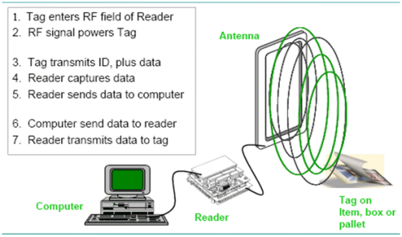

**4.8.4.Advantages of RFID:**

RFID has distinct advantages over the barcode. Which are given below.

* Human intervention is required to scan a barcode, whereas in most applications an RFID tag can be detected ʺhands off.ʺ
* Barcodes must be visible on the outside of product packaging. RFID tags can be placed inside the packaging or even in the product itself.
* You must have ʺline of sightʺ to read a barcode. RFID tagged items can be read even if they are behind other items. The readability of barcodes can be impaired by dirt, moisture, abrasion, or packaging contours. RFID tags are not affected by those conditions.
* RFID tags have a longer read range than barcodes.
* RFID tags have read/write memory capability; barcodes do not.
* More data can be stored in an RFID tag than can be stored on a barcode.

**4.8.5.Modulation:**

Data are communicated on an RF carrier wave via a process called modulation. In this process a stream of data pulses (ʺ1ʺs and ʺ0ʺs) are added to (mixed with) the carrier wave.

The data stream has a clock frequency that is much slower than the carrier wave frequency. For a 915 MHz system the data clock rate is 62.5 KHz, that is one clock pulse every 16 microseconds. The data clock will serve to synchronize the RFID tag with the RFID interrogator. There will be a data pulse every 16 microseconds.

Data pulses that are 2 microseconds wide will be interpreted as data bit ʺ0ʺs and pulses 6 microseconds wide will be interpreted as data bit ʺ1ʺs to make the data stream.



**Fig 27**



**Fig 28**

RFID NUMBER FORMAT - fig 29:



The header serves as a way of identifying the format of the sequence of bits that follow in the EPC. This makes system coding more flexible. That is a critical innovation because it allows for the use of various independent standards of identification to be understood by users of other formats.

**4.8.6.Antennas:**

The choice of interrogator antenna is influenced by the intended application. Antennas each have unique characteristics that benefit specific uses.

Antenna **polarization** refers to the orientation of the carrier wave as it travels through space. Antennae may have linear polarization or circular polarization. This is important as it relates to the orientation of your RFID tags on the asset being tracked.

Linearly polarized antennae radiate in only one plane. If the interrogator antenna and tag antenna are both linearly polarized andif the two antennas are at right angles to each other, the tag will not be read. If the tag is parallel to the reader it willbe read. However, the advantage of linearly polarized reader antennas is that they concentrate transmits power on the same plane, whereas circularly polarized antennas distribute power over a 360 degree cycle. So, if it is known that linear tags will always be in the same orientation (for example, on a product packaging conveyor) a linear reader antenna may be the preferred choice for better performance.

A Circularly polarized antenna cycles its electric field through 360 degrees and will read tags that are designed with either linear polarization or circular polarization characteristics. Circular antennas will read tags from just about any angle with respect to the interrogator antenna. That’s an advantage where tagged items of different shapes, sizes, and orientations are being interrogated by the reader.

.

**4.8.7.Advantages:**

There are many areas that benefit from the use of RFID. The technology can be used in Document Tracking Applications as a way to improve the management of important document files in industries like insurance and legal where the loss of such files can cause severe problems. RFID improves the tracking of documents so that files can be more quickly located and legal document workflow more easily tracked.

For sports events, concerts, and other leisure activities, RFID systems streamline ticket issue and validation. They also serve to minimize losses from ticket fraud. Tickets can be created on demand with RFID-enabled bar code printers; RFID card transponders can be issued to individual customers and enabled for specific time periods; and tickets can be read remotely to increase throughput at entrances and gates.

A hands-free access system for ski lifts based on RFID is used at many ski resorts in Europe. This allows for improved customer service, more efficient operations, increased sales and higher throughput of customers. Remote-operated gates detect a valid ski pass, embedded with a Tag-it read/write transponder, and open automatically. The credit-card sized ski pass fits into a jacket pocket and never has to be removed, giving skiers the freedom to enjoy hassle free skiing.

**4.9.PULSE WIDTH MODULATION (PWM):**

**Pulse-width modulation (PWM)**, or **pulse-duration modulation (PDM)**, is a commonly used technique for controlling power to inertial electrical devices, made practical by modern electronic power switches.

The term duty cycle describes the proportion of 'on' time to the regular interval or 'period' of time; a low duty cycle corresponds to low power, because the power is off for most of the time. Duty cycle is expressed in percent, 100% being fully on.

The main advantage of PWM is that power loss in the switching devices is very low. When a switch is off there is practically no current, and when it is on, there is almost no voltage drop across the switch. Power loss, being the product of voltage and current, is thus in both cases close to zero. PWM also works well with digital controls, which, because of their on/off nature, can easily set the needed duty cycle. PWM has also been used in certain communication systems where its duty cycle has been used to convey information over a communications channel.

One of the advantages of PWM is that the signal remains digital all the way from the processor to the controlled system. By keeping the signal digital, noise effects are minimized. Noise can only affect a digital signal if it is strong enough to change a logic-1 to a logic-0, or vice versa.

Increased noise immunity is yet another benefit of choosing PWM over analog control, and is the principal reason PWM is sometimes used for communication. Switching from an analog signal to PWM can increase the length of a communications channel dramatically. At the receiving end, a suitable RC (resistor-capacitor) or LC (inductor-capacitor) network can remove the modulating high frequency square wave and return the signal to analog form. PWM is economical, space saving, and noise immune.

### 4.9.1.PWM controllers

Many microcontrollers include on-chip PWM controllers. For example, [Microchip](http://www.microchip.com)'s PIC16C67 includes two, each of which has a selectable on-time and period. The duty cycle is the ratio of the on-time to the period; the modulating frequency is the inverse of the period. To start PWM operation, the data sheet suggests the software should:

* Set the period in the on-chip timer/counter that provides the modulating square wave
* Set the on-time in the PWM control register
* Set the direction of the PWM output, which is one of the general-purpose I/O pins
* Start the timer
* Enable the PWM controller

**CHAPTER 5**

**SOFTWARE DESCRIPTION**

This project is implemented using following software’s:

* Express PCB – for designing circuit
* PIC C compiler - for compilation part
* Proteus 7 (Embedded C) – for simulation part

**5.1 Express PCB:**

Express PCB is a software tool to design PCBs specifically for manufacture by the company Express PCB (no other PCB maker accepts Express PCB files). It is very easy to use, but it does have several limitations.

Express PCB has been used to design many PCBs (some layered and with surface-mount parts. Print out PCB patterns and use the toner transfer method with an Etch Resistant Pen to make boards

**5.1.1 Preparing Express PCB for First Use:**

Click View -> Options. In this menu, setup the units for “mm” or “in” depending on how you think, and click “see through the top copper layer” at the bottom. The standard color scheme of red and green is generally used but it is not as pleasing as red and blue.

**5.1.2 The Interface:**

When a project is first started you will be greeted with a yellow outline. This yellow outline is the dimension of the PCB. Typically after positioning of parts and traces, move them to their final position and then crop the PCB to the correct size. However, in designing a board with a certain size constraint, crop the PCB to the correct size before starting.

Fig: 3.1 show the toolbar in which the each button has the following functions:



**Fig 30: Tool bar necessary for the interface**

* The select tool: It is fairly obvious what this does..
* The zoom to selection tool: does just that.
* The place pad:. When this tool is selected the top toolbar will give you a large selection of round holes, square holes and surface mount pads.
* The place component: tool allows you to select a component from the top
* The place trace: tool allows you to place a solid trace on the board of varying thicknesses.
* The Insert Corner in trace: button does exactly what it says. When this tool is selected, clicking on a trace will insert a corner which can be moved to route around components and other traces.
* The remove a trace button is not very important since the delete key will achieve the same result.

**5.1.3 Design Considerations:**

A double sided board is more expensive to produce professionally, more difficult to etch on a DIY board, but makes the layout of components a lot smaller and easier. It should be noted that if a trace is running on the top layer, check with the components to make sure you can get to its pins with a soldering iron. Large capacitors, relays, and similar parts which don’t have axial leads can NOT have traces on top unless boards are plated professionally.

When using a double sided board you must consider which traces should be on what side of the board. Generally, put power traces on the top of the board, jumping only to the bottom if a part cannot be soldiered onto the top plane (like a relay), and vice- versa.Some projects like power supplies or amps can benefit from having a solid plane to use for ground. In power supplies this can reduce noise, and in amps it minimizes the distance between parts and their ground connections, and keeps the ground signal as simple as possible.

**5.2 PIC Compiler:**

PIC compiler is software used where the machine language code is written and compiled. After compilation, the machine source code is converted into hex code which is to be dumped into the microcontroller for further processing. PIC compiler also supports C language code.

It’s important that you know C language for microcontroller which is commonly known as Embedded C.

PIC C is not much different from a normal C program. In PIC, we will have a main function, in which all your application specific work will be defined. In case of embedded C, you do not have any operating system running in there. So you have to make sure that your program or main file should never exit. This can be done with the help of simple while (1) or for (;;) loop as they are going to run infinitely.

We have to add header file for controller you are using, otherwise you will not be able to access registers related to peripherals.

#include <16F877A.h> // header file for PIC 16F877A**//**

**5.3 Proteus:**

Proteus is software which accepts only hex files. Once the machine code is converted into hex code, that hex code has to be dumped into the microcontroller and this is done by the Proteus. Proteus is a programmer which itself contains a microcontroller in it other than the one which is to be programmed. #The program which is to be dumped in to the microcontroller is edited in proteus and is compiled and executed to check any errors and hence after the successful compilation of the program the program is dumped in to the microcontroller using a dumper.

**5.4** **Procedural steps for compilation, simulation and dumping**:

**5.4.1 Compilation and simulation steps:**

For PIC microcontroller, PIC C compiler is used for compilation. The compilation steps are as follows:

* Open PIC C compiler.
* You will be prompted to choose a name for the new project, so create a separate folder where all the files of your project will be stored, choose a name and click save.
* Click **Project, New**, and something the box named 'Text1' is where your code should be written later.
* Now you have to click 'File, Save as' and choose a file name for your source code ending with the letter '.c'. You can name as 'project.c' for example and click save. Then you have to add this file to your project work.
* You can then start to write the source code in the window titled 'project.c' then before testing your source code; you have to compile your source code, and correct eventual syntax errors.
* By clicking on compile option .hex file is generated automatically.
* This is how we compile a program for checking errors and hence the compiled program is saved in the file where we initiated the program.

After compilation, next step is simulation. Here first circuit is designed in Express PCB using Proteus 7 software and then simulation takes place followed by dumping. The simulation steps are as follows:

* Open Proteus 7 and click on IS1S6.
* Now it displays PCB where circuit is designed using microcontroller. To design circuit components are required. So click on component option.

Now click on letter ’p’, then under that select PIC16F72 ,other components related to the project and click OK. The PIC 16F877A will be called your “*'*Target device*”,* which is the final destination of your source code.

**5.4.2 Dumping steps:**

The steps involved in dumping the program edited in proteus 7 to microcontroller are shown below:

1. Initially before connecting the program dumper to the microcontroller kit the window is appeared as shown below.
2. Select Tools option and click on Check Communication

3. After connecting the dumper properly to the microcontroller kit the window is appeared as shown below.

4. Again by selecting the Tools option and clicking on Check Communication the microcontroller gets recognized by the dumper and hence the window is as shown below. 5. Import the program which is ‘.hex’ file from the saved location by selecting File option and clicking on ‘Import Hex’ as shown in below window.

6. After clicking on ‘Import Hex’ option we need to browse the location of our program and click the ‘prog.hex’ and click on ‘open’ for dumping the program into the microcontroller.

7. The program is dumped successfully.

**CHAPTER 6**

**FACE RECOGNITION**

**6.1. MATLAB**

**6.1.1.Introduction:**

MATLAB is one of the most powerful software available today for signal and image processing, and many other electrical, electronic and computer based applications. MATLAB is a high-level technical computing language and interactive environment for algorithm development, data visualization, data analysis, and numeric computation. Using the MATLAB product, you can solve technical computing problems faster than with traditional programming languages, such as C, C++, and Fortran.

MATLAB provides a number of features for documenting and sharing the work. We can integrate our MATLAB code with other languages and applications, and distribute the MATLAB algorithms and applications.

**Key Features**

* High-level language for technical computing
* Development environment for managing code, files, and data
* Interactive tools for iterative exploration, design, and problem solving
* Mathematical functions for linear algebra, statistics, Fourier analysis, filtering, optimization, and numerical integration
* 2-D and 3-D graphics functions for visualizing data

**Image formats supported by Matlab**

The following image formats are supported by Matlab:

* BMP
* HDF
* JPEG
* PCX
* TIFF
* XWB

#### 6.1.2. Intensity image (gray scale image)

This is the equivalent to a "gray scale image" and this is the image we will mostly work with in this course. It represents an image as a matrix where every element has a value corresponding to how bright/dark the pixel at the corresponding position should be colored. There are two ways to represent the number that represents the brightness of the pixel: The double class (or data type). This assigns a floating number ("a number with decimals") between 0 and 1 to each pixel. The value 0 corresponds to black and the value 1 corresponds to white. The other class is called uint8 which assigns an integer between 0 and 255 to represent the brightness of a pixel. The value 0 corresponds to black and 255 to white. The class uint8 only requires roughly 1/8 of the storage compared to the class double. On the other hand, many mathematical functions can only be applied to the double class. We will see later how to convert between double and uint8.

#### 6.1.3 Binary image

This image format also stores an image as a matrix but can only color a pixel black or white (and nothing in between). It assigns a 0 for black and a 1 for white.

#### 6.1.4 Indexed image

This is a practical way of representing color imagesThe first matrix has the same size as the image and one number for each pixel. The second matrix is called the color map and its size may be different from the image

**6.2.MATLAB’s image arithmetic functions**

* imadd (A, B): add two images A and B (equivalent to A + B, due to an operator overload
* imsubtract(A, B): Subtract two images A and B (equivalent to A - B, but again not recommended since it won't work without the toolbox)
* immultiply(A, B): Multiply two images A and B
* imdivide(A, B): Equivalent to A/B (but the values are *rounded* to the nearest integer, not *truncated* like true integer arithmetic)
* imlincomb(K1, A1, K2, A2, ..., C): Linear combinations of images A1, A2, etc. This means you end up with *K*1 * *A*1 + *K*2 * *A*2 + ... + *C*.

**6.3. KEKRE TRANSFORM**

This is the transformation technique that is used in the proposed facial recognition system.

CBIR technology is implemented in a host of different applications which include art galleries, museums, archaeology architecture/engineering design, geographic information systems , weather forecast , medical imaging , trademark databases , criminal records , World Wide Web like photo sharing and video streaming sites. The goal of Content-Based Image Retrieval (CBIR) systems is to operate on collections of images and, in response to visual queries, extract relevant image. The typical CBIR system performs two major tasks . The first one is feature extraction (FE), where a set of features, called image signature or feature vector, is generated which describes the image stored in the library extensively. A feature vector is much smaller in size than the original image, typically of the order of hundreds of elements The second task is similarity measurement (SM), where a distance between the query image and each image in the database using their signatures is computed so that the most relevant images can be retrieved

Kekre Transform matrix is the generic version of Kekre’s LUV color space matrix Kekre Transform matrix can be of any size NxN, which need not have to be in powers of 2. All upper diagonal and diagonal values of Kekre’s transform matrix are one, while the lower diagonal part except the values just below diagonal is zero. Generalized NxN Kekre Transform matrix can be given as...

Fig.31 kekre transform matrix

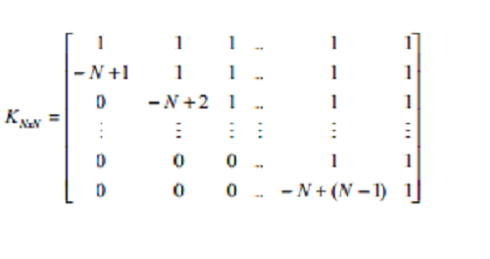

The formula for generating the term Kxy of Kekre Transform matrix is

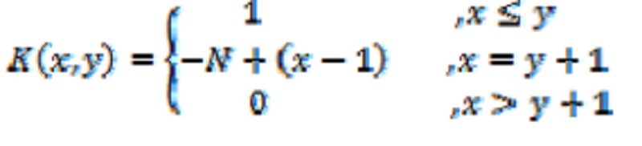

Image retrieval mainly has two steps Feature Extraction and Query Execution. Mainly three different techniques are used here for image retrieval, which are listed below.

• Kekre Transform Row Mean,

• Kekre Transform Column Mean and

• Kekre Transform Combination.

Here first the row mean and column mean of an image are found and then discrete cosine transform is applied on them to get feature vectors of image for respective technique of image retrieval Row Mean and Column Mean Extraction.The row mean vector is the set of averages of the intensity values of the respective rows. The column mean vector is the set of averages of the intensity values of the respective columns. the sample image with 4 rows and 4 columns, the row and column mean vectors for this image will be as given below.

Row Mean Vector = [Avg(Row 1), Avg(Row 2), …., Avg(Row n)]

Column Mean Vector = [Avg(Col. 1), Avg(Col. 2), …., Avg(Col. n)]

Fig.32. sample image template

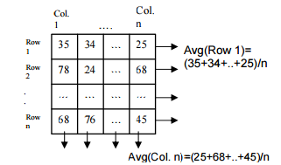

The Kekre Transform can be applied to the row mean and column mean vectors of image to get Kekre Transform row mean and Kekre Transform column mean feature vectors respectively. For Kekre Transform combination, the Kekre Transform row mean and Kekre Transform column mean feature vectors are considered together. The generated Kekre Transform coefficients will be playing the role of feature vectors of the image which can further be used for image retrieval. Thus features of all images in the database are obtained and stored in feature vector tables for all three different image retrieval techniques, Kekre Transform row mean, Kekre Transform column mean and Kekre Transform combination.

Here first the row mean of query image is obtained. Then the Kekre Transform row mean feature vector of query image is obtained by applying Kekre Transform on row mean. For image retrieval using Kekre Transform row mean, these query image features are compared with Kekre Transform row mean features of image database by finding Euclidian distances using the formula given as equation

**6.3.1. FEATURE EXTRACTION**

A. Even-Odd plane designing The components of Full Kekre transformed image shown in the red bordered area are considered for feature vector generation. The average value of zeoeth row, column and last row and column components are considered only for augmentation purpose. We have used color codes to differentiate between the co-efficient plotted on even plane as light red and light blue for co-efficient belonging to Odd plane. The co-efficient with light red background i.e. at position (1,1),(2,2);(1,3),(2,4) etc. are taken as X1 and Y1 respectively and plotted on Even plane. The coefficient with light blue background i.e. at position (2,1),(1,2);(2,3),(1,4) etc. are taken as X2 and Y2 respectively and plotted on Odd plane

Fig 33:.Kekre component arrangement

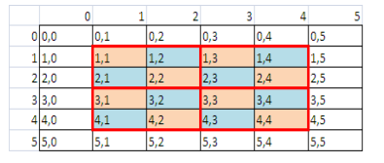

Even plane of Full Kekre transformed image is generated with taking transformed components into consideration as all X(i,j), Y(i+1, j+1) components for even plane and all X(i+1, j), Y(i, j+1) components for odd plane as shown in the Figure 2. Henceforth for our convenience we will refer X(i,j) = X1, Y(i+1,j+1) =Y1 and X(i+1,j) = X2 and Y(i,j+1) = Y2.

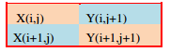

the Even plane of Full Kekre transform considers X1 i.e. all light red background cells (1,1), (2,2),(1,3),(2,4) etc. on X axis and Y1 i.e. (1,2), (2,1),(1,4),(2,3) etc. on Y axis. The Odd plane considers X1 i.e. all light blue background cells (1,2), (2,1),(1,4),(2,3) etc. on X axis and Y1 i.e. (1,2), (2,1),(1,4),(2,3) etc. on Y axis.

The procedure of 8,12 and 16 sector generation discussed in the is followed in for Kekre transform sectorization in this paper. Once the feature vector is generated for all images in the database a feature database is created. A query image of each class is produced to search the database. The image with exact match gives minimum sum of absolute difference/Euclidian distance. To check the effectiveness of the work and its performance with respect to retrieval of the images we have calculated the precision and recall as given in Equations (2) & (3) below along with this we have also used two more performance evaluation parameters namely length of initial relevant string of images (LIRS) and Length of string to recover all relevant images (LSRR) in the database as given in equation (4) and (5).

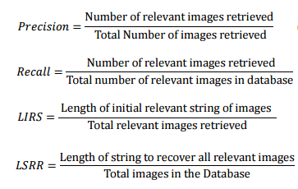

A query image of each class is produced to search the database. The image with exact match gives minimum sum of absolute difference/Euclidian distance.

These Euclidian distances are sorted in ascending order and result images are grouped together to get the precision and recall.

All these parameters lie between 0-1 hence they can be expressed in terms of percentages. Retrieval rate for particular class can be better only if it achieves higher value of LIRS and Lower value of LSRR

**CHAPTER 7**

**SCHEMATIC**

In this chapter, schematic diagram and interfacing of PIC16F72 microcontroller with each module is considered**.**

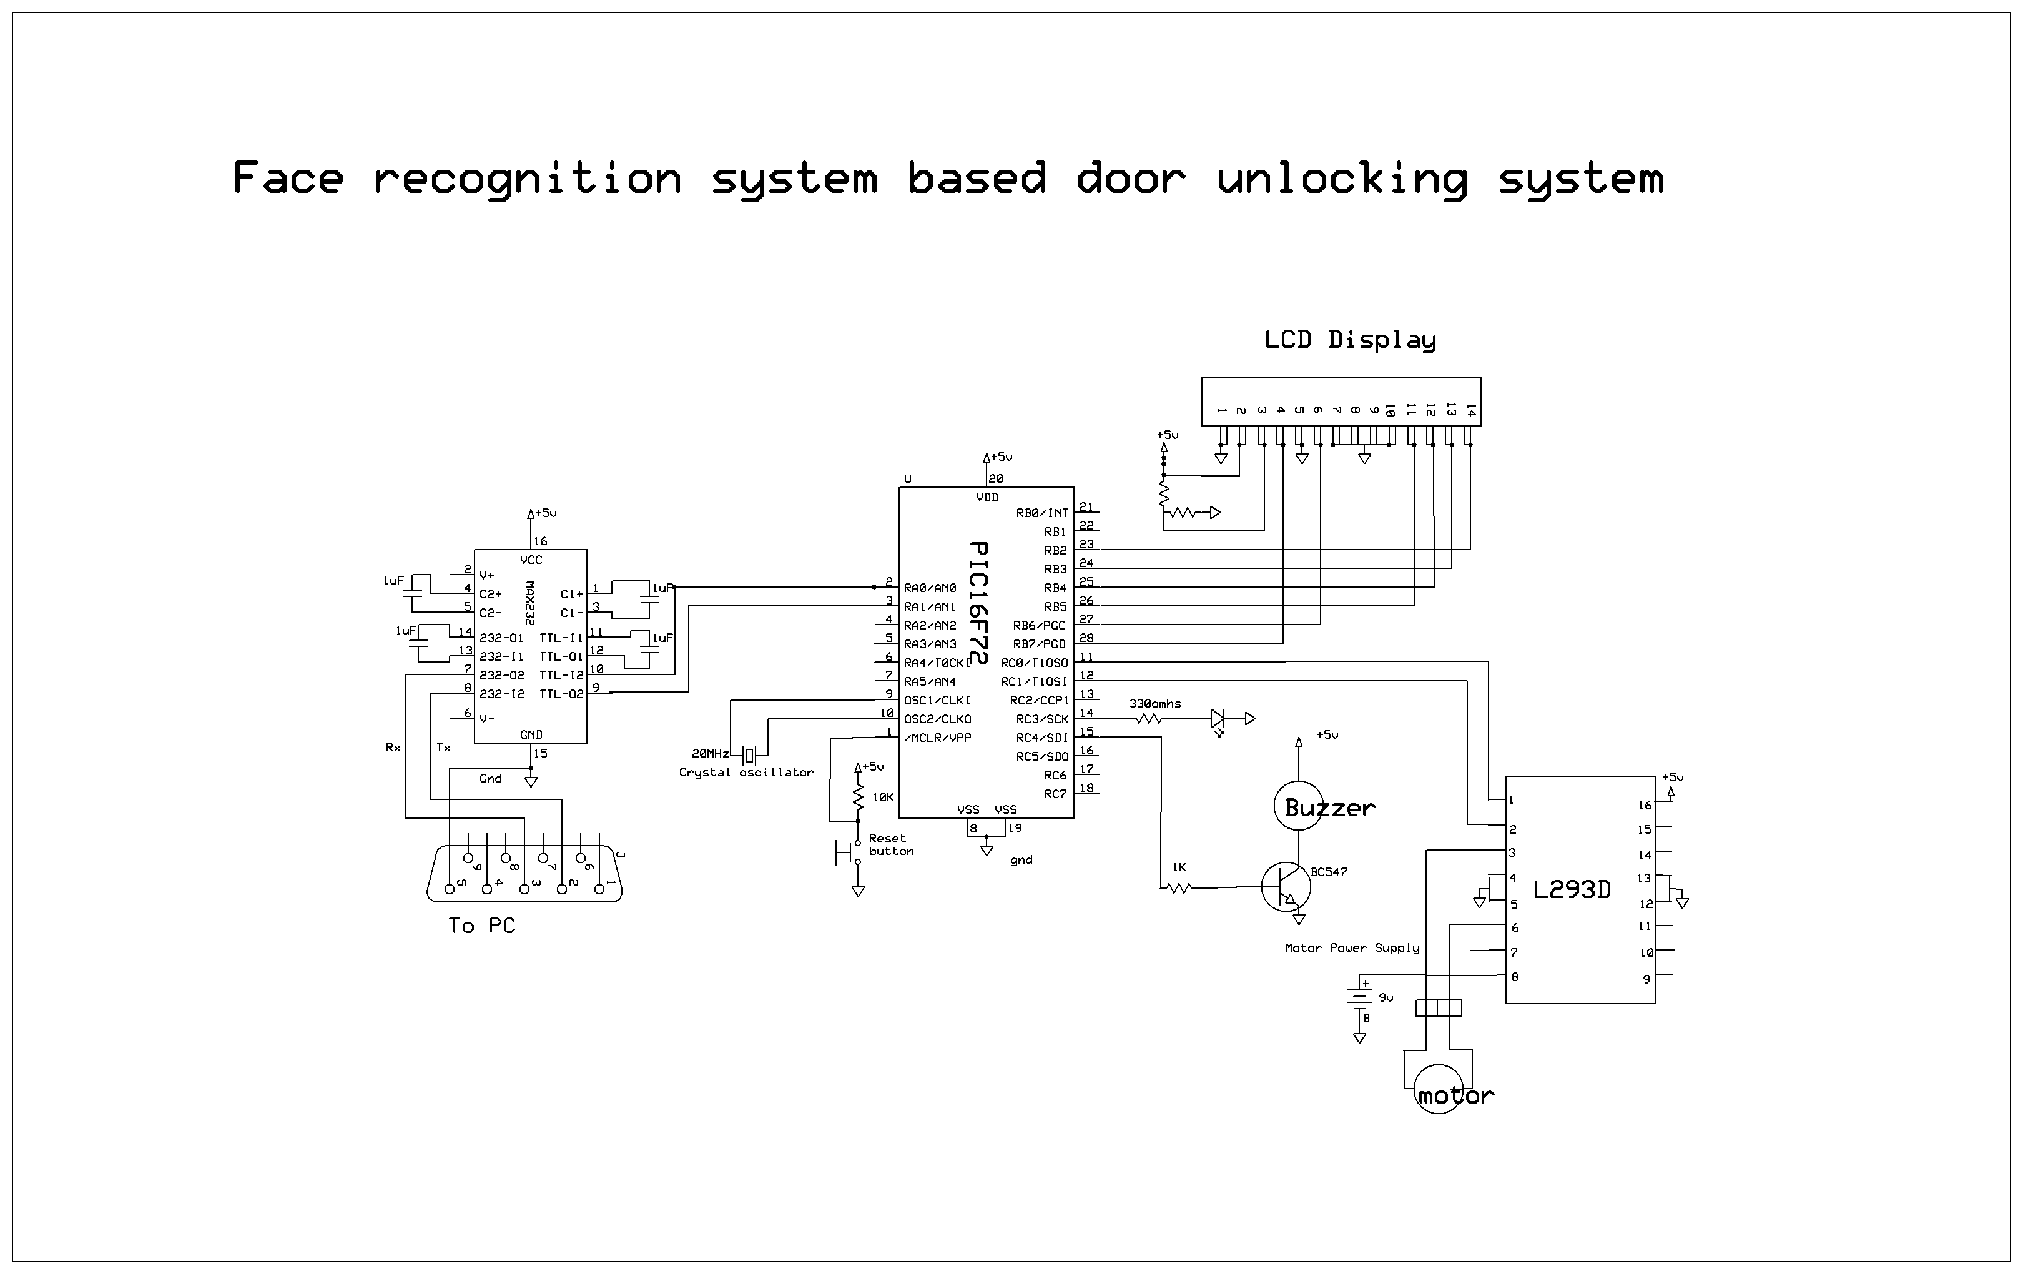

**Fig 34: schematic diagram of Face recognition system based door unlocking system**

The above schematic diagram of Face recognition system based door unlocking system

explains the interfacing section of each component with micro controller, RFID and DC motor. Crystal oscillator connected to 9th and 10th pins of micro controller and regulated power supply is also connected to micro controller and LED’s also connected to micro controller through resistors.

**CHAPTER 8**

**WORKING MECHANISM**

The project developed is controlled using the PIC 16f72a microcontroller, working with different hardware and software components like RFID readers and tags, L293D motor drivers, buzzers, led’s, LCD, Regulated power supply, USB to TTL converter for the serial conversion and the Matlab software for the execution of the facial recognition part.

Initaially, the PIC controller is coded with the required code that includes the functioning of circuitry. The Rfid tag Numbers are associated in the code. Parallely a set of images corresponding to different users are stored in the created database in matlab file. These set of images constitute the different images of same user. Set of images of two users are used in the database. The set is associated with a particular ID no. This ID no. Matches to a valid Rfid tag no. in the code.

When the circuit is switched on the LED blinks showing the health of the circuit which is in running condition. The lcd display shows the request for presenting the rfid tag in front of the reader. Once the tag is placed near the reader, the reader reads the number and is sent for processing to the controller.If the Rfid Tag number matches with the already existing number given in to the microcontroller, the controller directs the signal to the Matlab program being run on the PC. If the Rfid tag no. doesn’t match the number in the code then the access is denied thereby resulting in a beep sound.

In PC the query image is captured using the webcam. This image is then processed by the matlab software for feature extraction which approximately takes about 20seconds. Once the Feature vectors of the query image is obtained, it is checked with the ID no. associated with that representing set of image.

If the feature vectors of the query image matches with that of the set of feature vectors of set of images in the database then the access is granted. The Matlab window and the LCD shows the “Access Granted” message . Now the control is sent to the microcontroller, where is sends a sigbal to the motor driver. The driver operates the motor connected to it with the help of a +5v supply from the battery. The motor rotates for a particular amount of time depicting the opening of the door.

**CHAPTER 9**

**RESULTS**

PROJECT SETUP

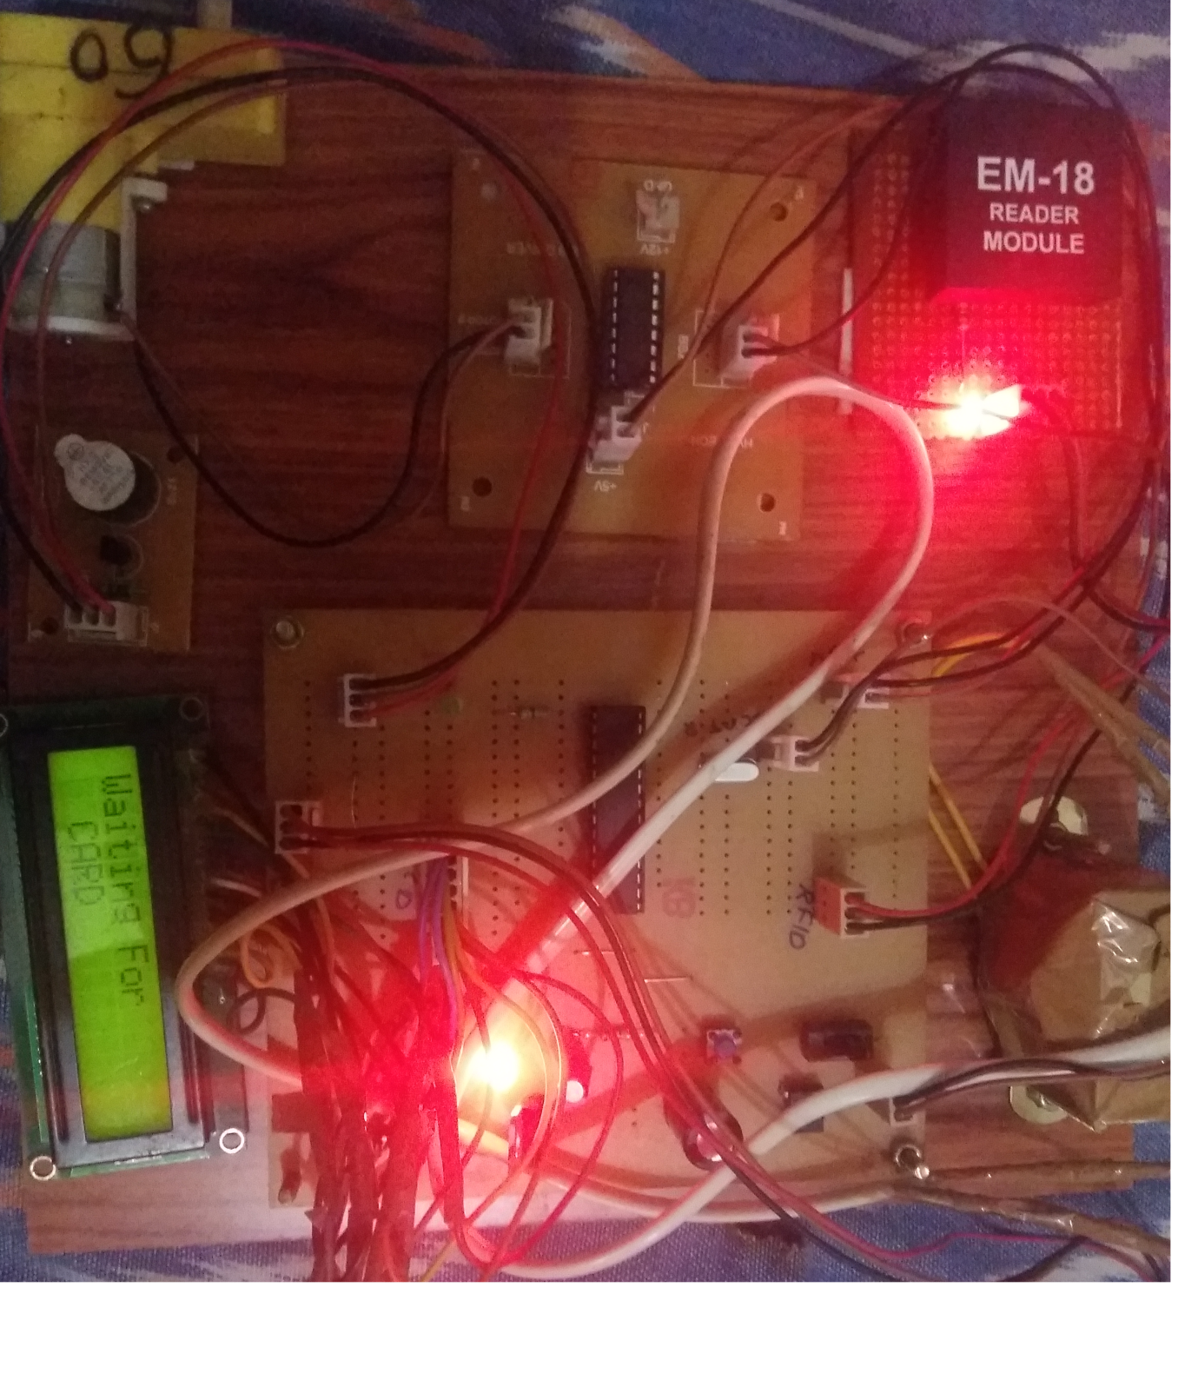

Database Images

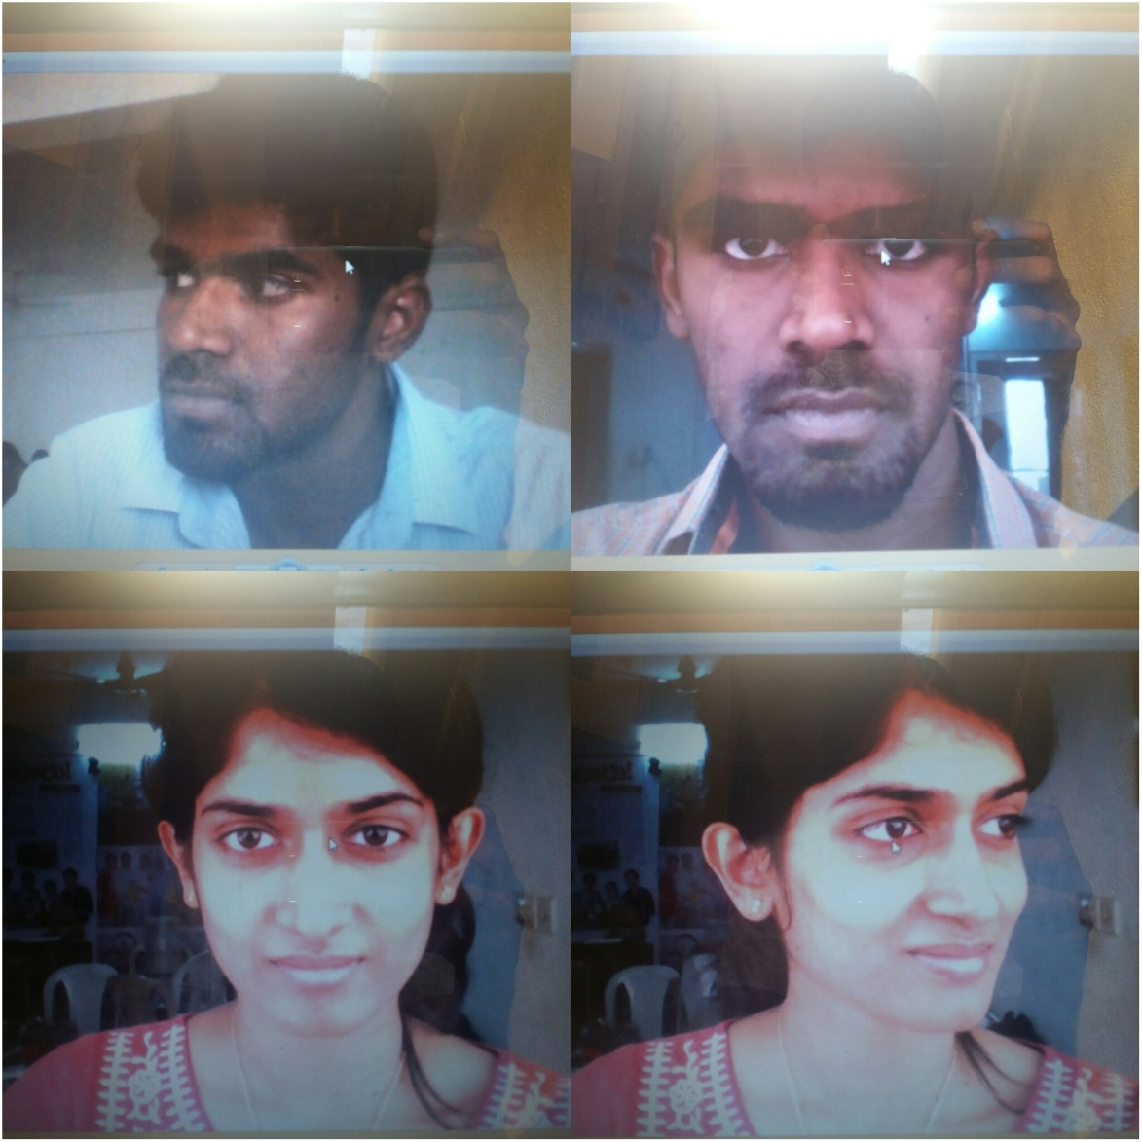

Waiting for Rfid card scanning:

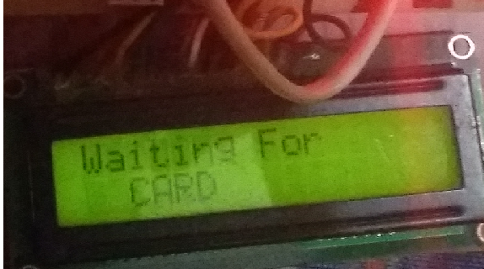

After the card is scanned:

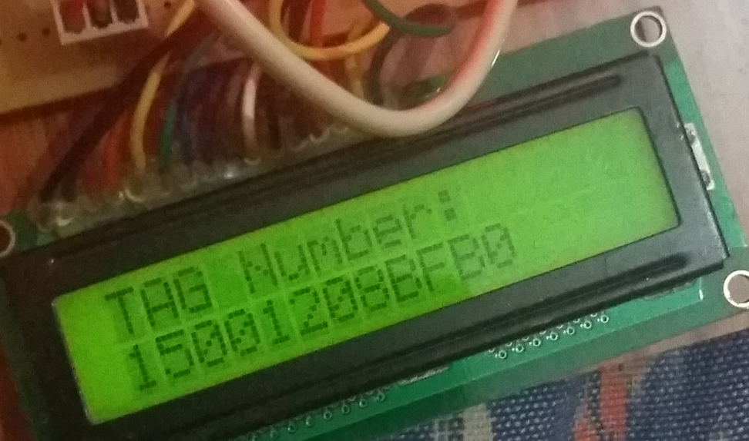

Waiting for Face recognition:

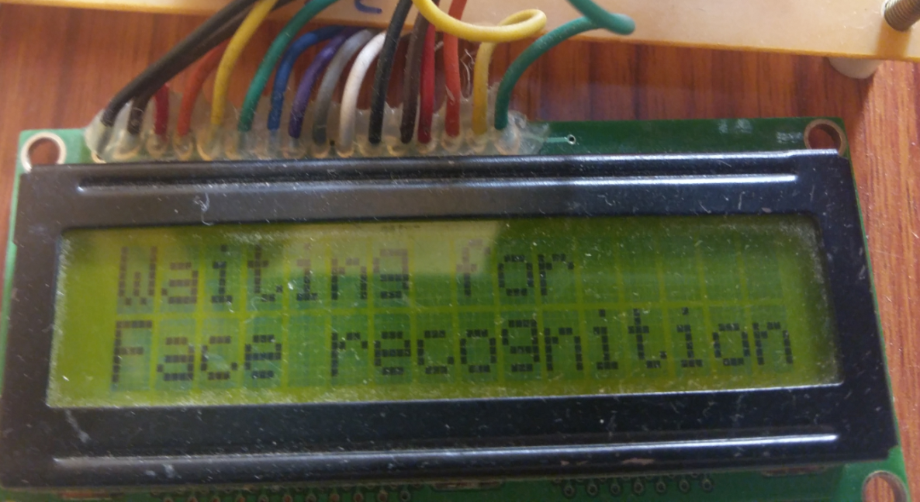

If the given query image matches with the database images:



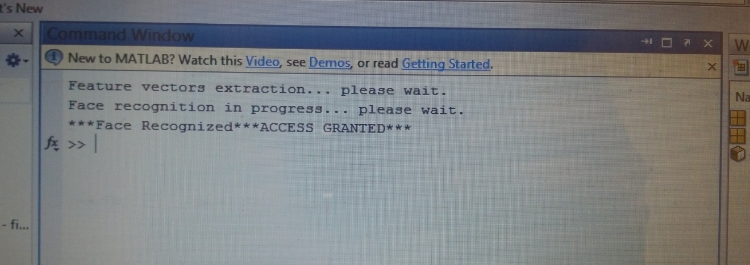

If the given query image doesn’t match the database images:





**CHAPTER 10**

**ADVANTAGES and DISADVANTAGES**

**10.1.Advantages**

* Highly efficient and user friendly design.
* Easy to operate.
* Real time authentication system
* Highly sensitive.
* Beep based alert sound, if user identity is not in database.
* Development of highly secure and intelligent door unlocking system.

**10.2. Disadvantages**

* Delay in the facial vectors extraction process.
* Project not compatible on other versions.
* Facial recognition may face problems when the query images have changes like lighting, angle, noise etc.

**CHAPTER 11**

**CONCLUSION AND FUTURE SCOPE**

**11.1 Conclusion**

Integrating features of all the hardware components used have been developed in it. Presence of every module has been reasoned out and placed carefully, thus contributing to the best working of the unit. Secondly, using highly advanced IC’s with the help of growing technology, the project has been successfully implemented. Thus the project has been successfully designed and tested.

The Project has been successfully tested for various kinds of inputs both in the Rfid and the query images. We have been able to study the RFID technology and successfully implement it. This project helped us learn about the face recognition process using the matlab software. It has given us much to learn about the PIC controller architecture, the understanding of the controller part and the coding part related with its software. Serial communication implemented was a different on eas compared to the conventional rs232 standard. With the help of USB to TTL conversion we differently employed the serial communication in our project.

The Project developed uses various kinds of hardware and technological inputs to deploy a working model of a two level security access control system.

**11.2. Future scope**

The project can be extended using GPRS technology. The system sends messages to the predefined weblink. In this type of future scope the two level proposed security access control system can be operated using the internet through which the owner can control the system over long ranges just by using the lan and other services.

The project can be extended using wireless camera which can detect the person through camera. The wireless camera then sends the pictures of the person to the destined IP address.

REFERENCES

[1]. <http://www.ijirset.com/upload/2013/november/6_RFID.pdf>

[2]. <http://www.ijcee.org/papers/260-E272.pdf>

[3]. <http://www.ijetch.org/papers/283-T793.pdf>

[4]. <http://www.engineersgarage.com/articles/pic-microcontroller-tutorial>

[5]. <http://www.instructables.com/id/Intro-to-RFID/>

[6].<http://www.extremeelectronics.co.in/avrtutorials/pdf/avr_tutorial7---motor-control.pdf>

[7]. <https://electrosome.com/interfacing-lcd-with-pic-microcontroller-hi-tech-c/>

[8]. <http://in.mathworks.com/matlabcentral/fileexchange/32284-face-recognition-system-using-kekre-transform>

*BIBLIOGRAPHY*

**CODE**

#include <16F72.h>

#fuses HS,NOWDT,PROTECT,brownout,put

#include <string.h>

#include <lcd.h>

#include <RFID.h>

#include <DC.h>#use delay (clock=20000000)

#use RS232(baud=9600, xmit=PIN_A0, rcv=PIN_A1, stream= PC)// for PC

unsigned long duty = 0;

#use delay(clock=20000000) //Crystal oscillator used

#use RS232(baud=9600, xmit=PIN_B0,rcv=PIN_B1,stream=RFID) //RFID Reader connectivity

int money = 0;

char user_1[] = "15001208BFB0";

char user_2[] = "15001208BFB1";

char data[170];

char user[15];

void start()

{

lcd_putc('\f');

lcd_gotoxy(1,1);

printf(lcd_putc," WELCOME");

lcd_gotoxy(1,2);

printf(lcd_putc," TO");

delay_ms(2000);

lcd_putc('\f');

lcd_gotoxy(1,1);

printf(lcd_putc," RFID and Face ");

lcd_gotoxy(1,2);

printf(lcd_putc," Security");

delay_ms(1000);

}

void main()

{

lcd_init();

lcd_putc('\f'); //Clear LCD

lcd_gotoxy(1,1);

printf(lcd_putc, "Face detection ");

lcd_gotoxy(1,2);

printf(lcd_putc," door access ");

delay_ms(2000);

output_high(PIN_C3);

delay_ms(1000);

output_low(PIN_C3);

delay_ms(1000);

output_high(PIN_C3);

delay_ms(1000);

output_low(PIN_C3);

while(1)

{

if((input(PIN_A0)) && (input(PIN_B0)))

{

output_high(PIN_C3);

output_high(PIN_C4);

delay_ms(700);

output_low(PIN_C4);

Motor_M1_On(1); //1=forward, 0=reverse

lcd_putc('\f'); //Clear LCD

lcd_gotoxy(1,1);

printf(lcd_putc,"Door open ");

lcd_gotoxy(1,2);

printf(lcd_putc," Please check ");

//delay_ms(2000);

}

else if(input(PIN_A0))

{

output_high(PIN_C3);

output_high(PIN_C4);

delay_ms(300);

output_low(PIN_C4);

Motor_M1_On(0); //1=forward, 0=reverse

lcd_putc('\f'); //Clear LCD

lcd_gotoxy(1,1);

printf(lcd_putc," Door close ");

lcd_gotoxy(1,2);

printf(lcd_putc," Please check ");

//delay_ms(2000);

}

else if(input(PIN_A0))

set_pwm1_duty(0);

i = 0;

break;

delay_ms(300);

}

}